Enter Plan Data into Workbook
Plan details are Researchers’ plan for spending project money in accordance with contract guidelines and attached spending rules. The Budget and Forecast Workbook is used to load Plan into the Reportal (Business Objects) and reflected on the Research and Consulting Balance (aka MyBalance) Dashboard.

To populate MyBalance Reports the following steps need to take place:

- Forecast is entered in the Workbook using the existing Edit, Staff and Transfers functions. Traffic light indicators can be attached to a chartstring combination through the use of Link Type indicators when linking to the Transfers tab. Spending rules are entered as Plan Notes, either as a high level_1 commentary and/or as individual level_6 commentaries for each account row.

- Upon consultation with Researchers, Management Accountants can trigger the “Copy Forecast to Plan” functionality in the Workbook in order to generate the Plan. Once saved the updated Plan can be exported into the Reportal (Business Objects) for MyBalance reporting.

The Plan will remain static until overwritten by the Management Accountant in the Workbook (by overwriting the Plan with a revised Forecast). The Plan is not overwritten by Actuals and the Forecast can be changed without adjusting the Plan.

A material variance between the current Forecast and the last updated Plan is a trigger for review, seek input and provide advice to the Researcher.

Copying Plan Data into Workbook
In the Workbook On the ‘Edit’ worksheet –

- Select a chartstring to edit from the drop down box (blue shaded) in top left hand of the worksheet

- This will automatically load Latest Forecast for the selected chart string

Forecast columns:

The Edit tab can be linked to the Staff and Transfers tabs. Linking to the Staff tab is done using the current functionality in the Workbook (Please refer to Quick Reference Guide “Staff Plan – linking the staff plan”).

Linking to the Transfers tab now includes “Link Type” selection to generate Traffic light Indicators for the MyBalance report.

CREATING LINKS

There are two methods of setting up links on the Transfers works to the Edit tab:

1) Automatic Linking. This will create links to all valid chart string combinations referenced on the Transfers tab.
2) Single Link will link to the selected chart string only.

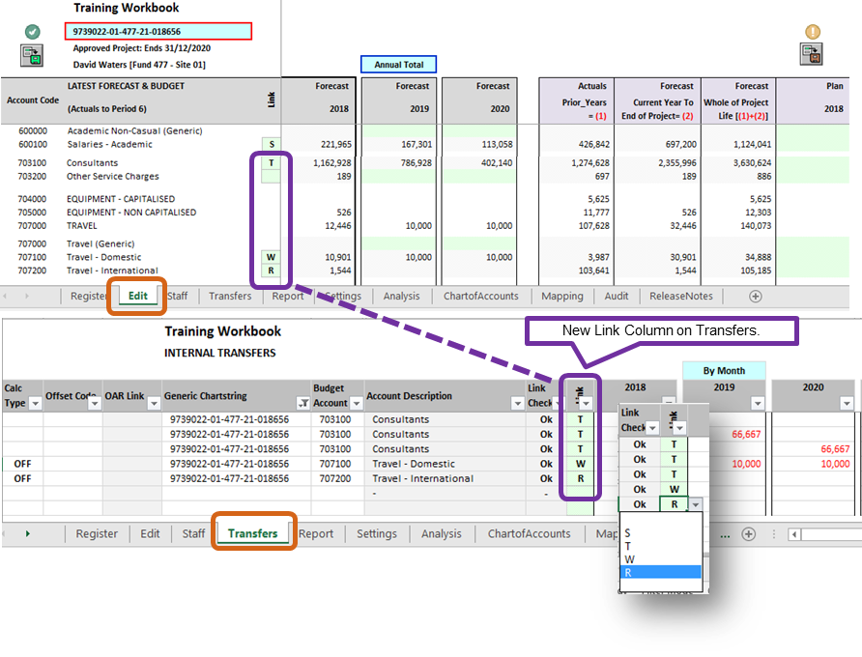

Users will need to select the Link Type on the Transfers before executing the Create Link routine on the Transfers tab.

The Link_Type selection will have references to the following Traffic Light Indicators on the MyBalance Report:

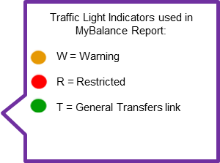

Please note any non-selection (ie. blank) of the Link_Type will default as “T” link.

Once the links have been created and Forecast updated on the Transfers worksheet, refreshing the Edit tab will show the latest Forecast. Users need to save the latest Forecast before copying to Plan.
COPYING FORECAST TO PLAN

Plan data are depicted as annual total amounts projecting out to 5 years with the outmost year containing the remainder of the project life.

Eg. If the current year is 2018, then year 2022 should contain plan amounts for 2022 and onwards

Plan columns (columns CB to CF):

TIP – Clicking will show/hide project details (columns BY to CI) on Edit tab.

There are two methods of copying forecast to plan on the Edit tab:

- Reset Plan with Forecast will copy Forecast to Plan for the selected account row (Level 6 account).

- Reset Plan with Forecast for ALL account/rows will copy Forecast to Plan for ALL account rows except Undefined Project Expenses account.

Please Note the Original Budget does NOT get populated as part of the Copy routine. This will need to be entered manually.

Plan Notes can be added at the Level 1 chart string (cell CI8) and/or individual account level 6 chart string on the Edit tab.

Once all Plan have been updated and Spending Rules added to the Edit worksheet, Users will need to save the new Plan to the Workbook.
The Workbook is now ready for exporting Plan details to the Reportal (Business Objects).

EXPORTING PLAN TO THE REPORTAL (BUSINESS OBJECTS)

Ensure that the Settings tab reflect the latest workbook version and Last Actual Period. The Export Scenario needs to show “CUR” (ie. Current) before executing the Export routine. Please refer to Quick Reference Guide “Exporting forecast adjustments”) for further guidance or contact FPA should you require assistance fpa@fbs.uq.edu.au.
There are two methods of exporting Plan to Business Objects:

- Executing Export from the Edit Menu will export the saved Plan for the displayed chart string on the Edit worksheet to the Reportal. This include associated Forecast and linked Staff Plan and Transfers tabs for the selected chart string.

- Executing Export from the Settings Menu will export the ALL the saved Plan in the Workbook to the Reportal. This include all Forecast saved in the Workbook along with the Staff and Transfers tabs.

The MyBalance Dashboard will now show the updated Plan, Spending Rules and Notes:

