Upgrade Workbook to New Version

When an upgrade for the workbook is required FPA will advise that an upgrade version is available – this will either be published on the “Budgeting, forecasting and reporting” website for download or sent via email.

Upgrades to the workbook are necessary periodically to enhance the Workbook and correct any bugs that’s may be identified.

Sequence for Upgrading

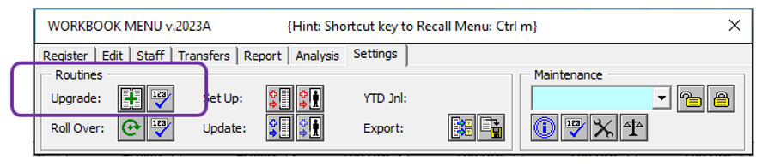

When an upgrade version is released, open your most recent version of the workbook and save the workbook as:

- File name: OLDWKB.xlsm

Note 1 - Take a note of the Version ID (this can be found on the Settings Tab):

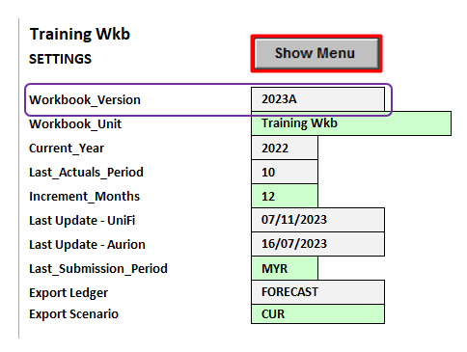

Note 2 - Ensure that you CLOSE down the Workbook Menu by clicking on X located on top RHS of the (oldwkb) Menu BEFORE proceeding to the next step:
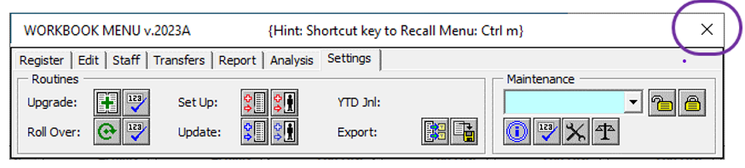
Download the latest version of the “Budget and Forecast Workbook (XLSM)” from email or the FPA website (as below) to your local server/PC:
https://coo.uq.edu.au/operational-areas/finance/finance-staff/budgeting-forecasting-and-reporting/budgeting-and-forecasting-workbook

From within the open session of Excel, open the new version of the workbook that you have just downloaded. Ensure that you also save to your server as Microsoft Excel Macro-Enabled Worksheet (*.xlsm) format;
(NOT as 97-2003 .xls format, this is no longer required).

Go to the "Settings" tab on the WORKBOOK MENU in the new version of the workbook and run the [Upgrade] function. This will copy the following across from the old workbook to the new version:

- Settings
- Register
- Staff Plan
- Transfers
- Forecast data.
- Plan data.

Confirm that all data have been copied across (including Staff Plan and Transfers details). This can be done by simply refreshing the Report tab on both Workbook and cross-referencing (see Tip below).

Finally if you have any non-standards worksheets that you use in your workbook these will need to be manually copied across to the new version.

TIP - Once the upgrade sequence is completed a good check before you start working in the new workbook is to go to the “Report” tab and run it for the whole school. Then do the same in your old workbook and make sure the two versions agree and the upgrade has been successful.
Note even though the [CoA] Audit function is run as part of the [Upgrade] routine, it is recommended that you re-run [CoA] after the [Upgrade] to clear out and update the Audit Report on the [Audit] tab.

The [CoA] Audit function checks and confirms that data in the workbook conforms to the latest Chart of Accounts as maintained on the [ChartofAccounts] tab.
Open the [Audit] tab, check the Audit Report and resolve any potential errors before proceeding with the [Update] routine. The following are notification examples of the Audit Report:

- CS is Missing from the Register tab for {Chartstring Combination}:
  - Generally OK – Normally indicates that you had a posting error and cleared it so that the balance is now NIL and there is no reason to maintain the Chartstring combination on the [Register] tab.

- Equity entry for {Chartstring Combination} has been removed
  - Equity (carry forward/retained earnings) balances are not stored as part of the [Forecast] data set in the new Workbook. This is to avoid confusion with the “Actual” situation as reported in UniFi.

- Duplicate CS reference {Chartstring Combination} has been merged
  - You can end up with duplicate keys if a L6 Minor Account Group is re-allocated from one L5 Major Account Group to another.

- Link Code for {Chartstring Combination} has been …
  - Simple corrections for capitalisation, zero entries and spaces.

- Non-numeric data removed from against {Chartstring Combination}
  - Basic data cleansing.
Once you are satisfied with the Audit Report, proceed with the [Update] process. Guidelines can be found under Quick Reference Guides – End-of-Month Workbook Update:

https://coo.uq.edu.au/operational-areas/finance/finance-staff/budgeting-forecasting-and-reporting/budgeting-and-forecasting-workbook

