**Instructions to upgrade and rollover from the 2023 to the 2024 version of the Forecast Workbook.**

Please read the **entire** workflow below before you begin to ensure you understand the process. You will need to run through all steps to completion.

## Step 1 – Upgrading to the New Version

* Open existing workbook and [Save As] “OLDWKB.xlsm” file*.*
* Open a copy of the latest version of the workbook *(which can be downloaded from* [*https://coo.uq.edu.au/files/4520/budget-forecast-workbook.xlsm*](https://coo.uq.edu.au/files/4520/budget-forecast-workbook.xlsm)*)* and [Save As] an appropriate name (.xlsm).
* On the Settings tab in your “OLDWKB.xlsm/s” file ensure the “**Current Year**” is **2023**:

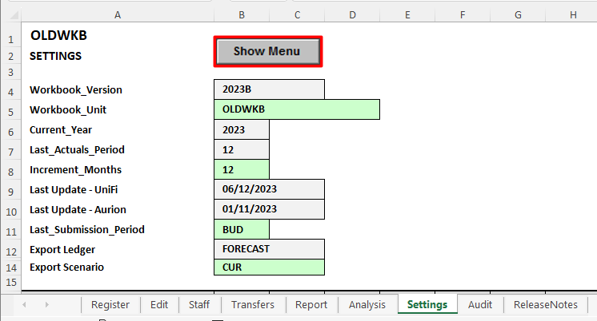

Close the {Menu Bar} for the “OLDWKB.xlsm” workbook. You will be able to tell them apart from the version number located on the top ribbon of the {Menu Bar}. Ensure only the latest {Menu Bar} is open:

*  From the 'Settings' tab on the {Menu Bar} execute the [Upgrade] function.

During this process a series of message boxes will appear depicting the status at each section of the routine. Some requiring acknowledgement eg. [OK] or decisions to be made eg. [Yes]/[No].

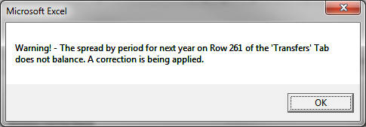

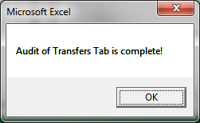

You should get a message at completion:

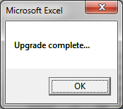

## Step 2 – Rollover to 2024 Year

From the 'Settings' tab on the {Menu Bar} execute the Roll Over.bmp [Rollover] function.

Scheduled salary increase for 2024 is 2% for EBA and 4.5% for Non-EBA. This needs to be entered as 1.02 for EBA and 1.045 for non-EBA (as below)*.*

**Rolling over in January 2024:**

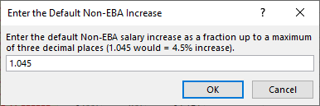

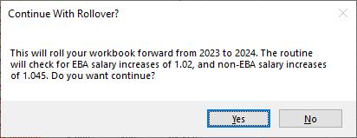

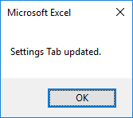

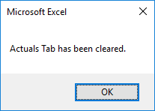

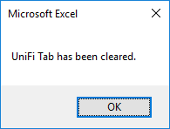

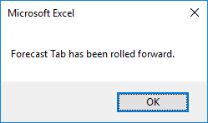

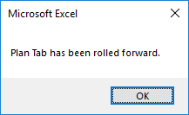

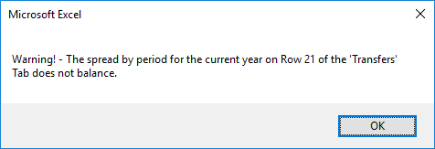

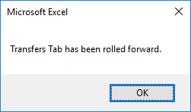

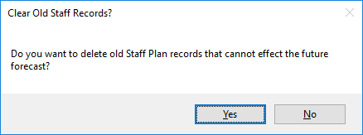

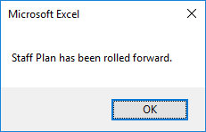

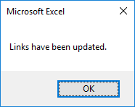

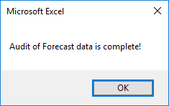

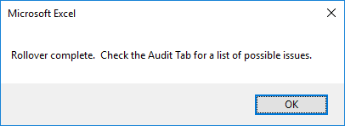

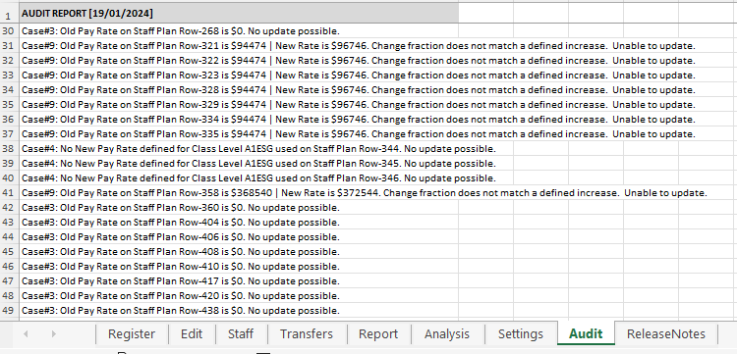

**Print and check the 'Audit' tab for issues before proceeding further. Work through the Audit Report and update accordingly ensuring that the Staff Plan and Transfers tab are up to date. If the forecasts have changed, ensure that you understand “the why” before proceeding to the next step. AT THIS POINT YOUR WORKBOOK SHOULD BE USEABLE BUT YOU WILL HAVE NO ACTUALS OR UNIFI BUDGET DATA. YOU WILL NEED TO PROCEED WITH STEP 3 TO POPULATE THE WORKBOOK WITH THESE DATASETS.**

## Step 3 – Updating UniFi Data

**Create Business Objects Reports (from the Reportal)**

Login to the Reportal ([*https://mis-xi4-web.mis.admin.uq.edu.au/BOE/BI*](https://mis-xi4-web.mis.admin.uq.edu.au/BOE/BI)) and then under directory

Finance > Workbook, you need to execute:

* “**Forecast Download – Unifi (2024)**” report. *(Save file as* ***dldunifi.xlsx*** *as per normal month end)*

**Save the report on the same folder as your 2024 Forecast Workbook**.

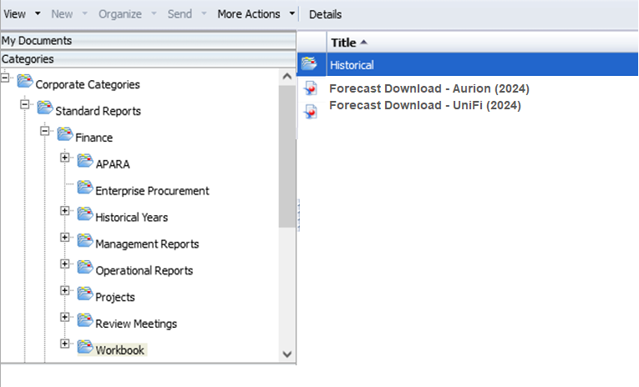

* While having both the dldunif.xls and Workbook **open**, from the 'Settings' tab on the {Menu Bar} execute the Import CS List.bmp [UniFi Update] function.

This process will update the Chartstring Register and also all data sets (Actuals & Budget) the workbook requires.

## Step 4 – Updating Aurion Data

Login to the Reportal ([*https://mis-xi4-web.mis.admin.uq.edu.au/BOE/BI*](https://mis-xi4-web.mis.admin.uq.edu.au/BOE/BI)) and then under directory: Finance > Workbook, you need to execute:

* “**Forecast Download – Aurion (2024)”** report. *(Save file as* ***dldaurion.xlsx*** *as per normal month end)*

**Save the report on the same folder as your 2024 Forecast Workbook**.

While having both the dldaurion.xlsx and Workbook open, from the 'Settings' tab on the {Menu Bar} execute the Update Staff Plan.bmp [Aurion Update] function.

This process will import and update your staff plan. You will see similar prompts from when you rolled over.

## Step 5 – Checking and Exporting to the Reportal

Your workbook has now been successfully:

* Upgraded to the new version
* Rolled over to 2024
* Had all of the new data imported.

Now review your workbook for accuracy and correctness.

## 1. Review and Update your Staff Plan

You need to check your staff plan for accuracy. Once you are satisfied with your staff plan, update the staff plan links. If you are unsure of how to do this please consult Quick Reference Guide – “Staff plan – linking the staff plan”, which can be found at:

<https://coo.uq.edu.au/files/4682/4c-linking-staff-plan-guide.docx>

## 2. Review your Transfers Tab to ensure all data has copied across correctly.

Once verified, update the Transfers tab links. If unsure of how to update these links, please consult Quick Reference Guide – “Transfers tab”, which can be found at:

<https://coo.uq.edu.au/files/4688/5-transfers-tab-guide.docx>

## 3. Export to the Reportal.

Once you have reviewed the Workbook and updated the links, you will need to execute the export routine to update the “**Current” scenario**. Please consult Quick Reference Guide – “Exporting forecast adjustments” if you are unsure of how to do this. This can be found at:

<https://coo.uq.edu.au/files/4625/7a-exporting-forecast-adjustments-guide.docx>

## 4. Check the Reportal.

Our suggestion is to run a Consolidated I&E Statement. The workbook report should match this report.

If you have any questions in regards to this process please contact the FPA Email address [fpa@fbs.uq.edu.au](mailto:fpa@fbs.uq.edu.au).

If you email us in regards to a technical question please include:

1. Your 2023 Workbook – before anything was done to it if possible
2. Your 2024 Workbook
3. Your 2024 DLDUNIFI.XLSX file
4. Your 2024 DLDAURION.XLSX file
5. The process followed
6. The issue/s that has occurred