A guide to using the Report tab

General Description
The Report Tab allows generation of an Income & Expenditure (I&E) Statement similar to one from the Reportal.
Drill functionality allows I&E Statement to be generated for different chartstring combinations including OPAL, Fund and Project variation combinations.

Report Level Settings
Changing the [Reporting Level] will alter the available selections.
I&E Reports can be generated by using the following Settings (Ensure that you click on Refresh after selection):

- Unit:
  - [L&] – ALL OPAL Units in the Workbook.
  - [L1] – Level 1 requires the first TWO OPAL Units (the remainder are wildcards ie. ‘&&&&&’) Eg.
  - [L2] – Level 2 requires the first FIVE OPAL Units (remainder are wildcards ie. ‘&&’) Eg.
  - [L3] – Level 3 is the lowest level. Individual OPAL Unit can be viewed. Eg.

- Site:
  - [L&] – ALL Site Codes in the Workbook.
  - [L3] – Level 3 is the only level for selection. Individual Site Code can be viewed. Eg.

- Fund:
  - [L&] – ALL Fund Codes in the Workbook.
  - [L1] – Level 1 is Fund Group Sub Category level. Eg.
  - [L2] – Level 2 is Minor Fund Group level. Eg.
  - [L3] – Level 3 is the lowest level. Individual Fund Codes can be viewed. Eg.

- Function:
  - [L&] – ALL Function Codes in the Workbook.
  - [L3] – Level 3 is the only level for selection. Individual Function Code can be viewed. Eg.

- Project:
  - [L&] – ALL Projects in the Workbook.
  - [L1] – Level 1. Use ‘000000’ for ALL Non-project OR ‘######’ for ALL Projects Only Eg.
  - [L2] – Level 2. Use ‘000000’ for ALL Non-project or ‘999999’ for ALL Budget Projects or ‘######’ for ALL Non-budget Projects
  - [L3] – Level 3 is the lowest level. Individual Project Code can be viewed.

Report Examples:
- Example of Report showing the first two OPAL Units: OPAL Units beginning with ‘10’

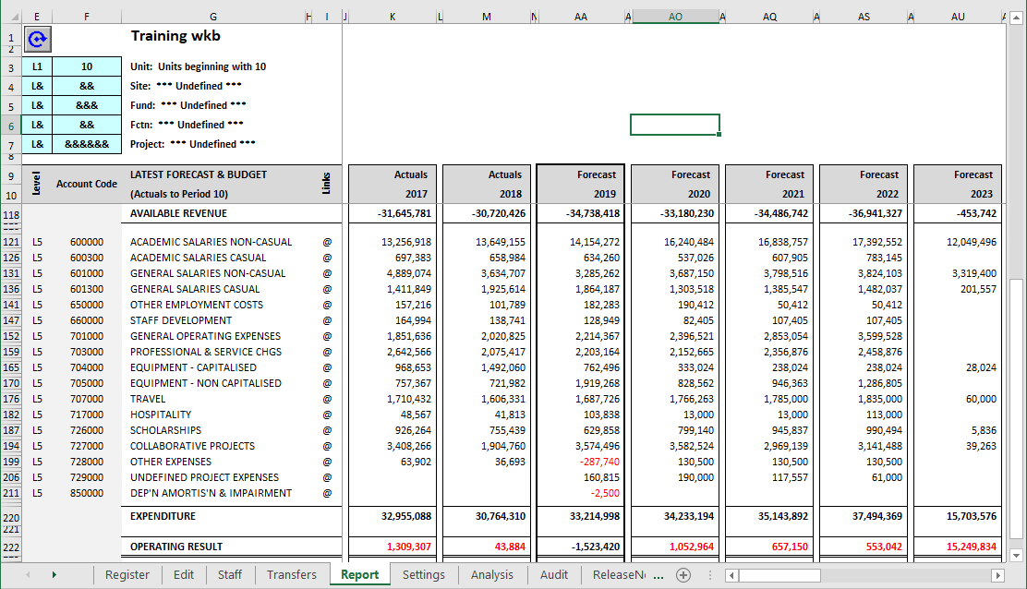

- Example of OPERATING FUND GROUP Report

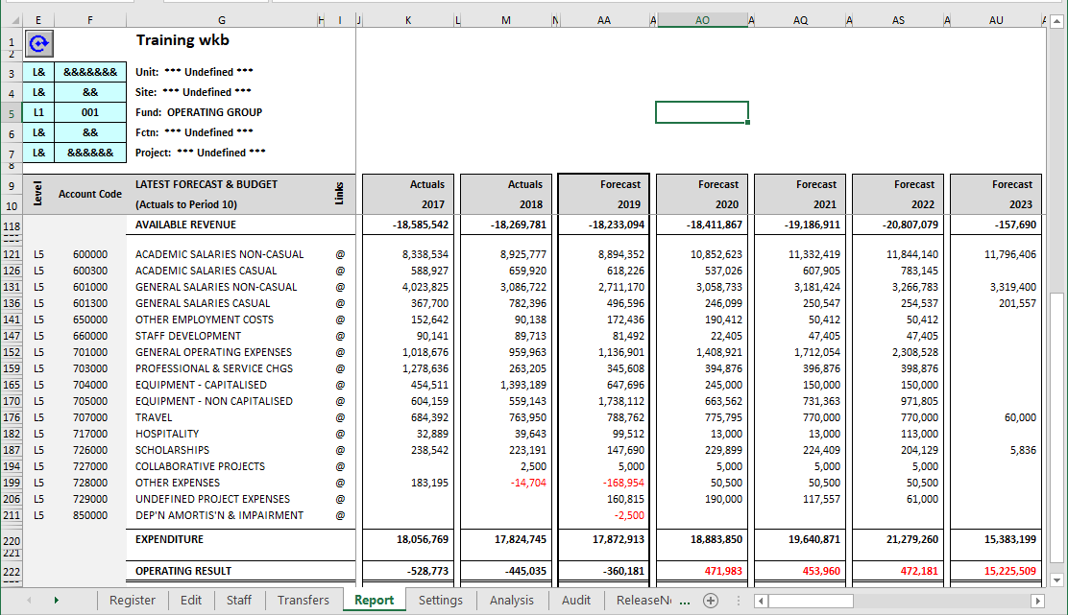

- Example of Report showing All Non-Projects

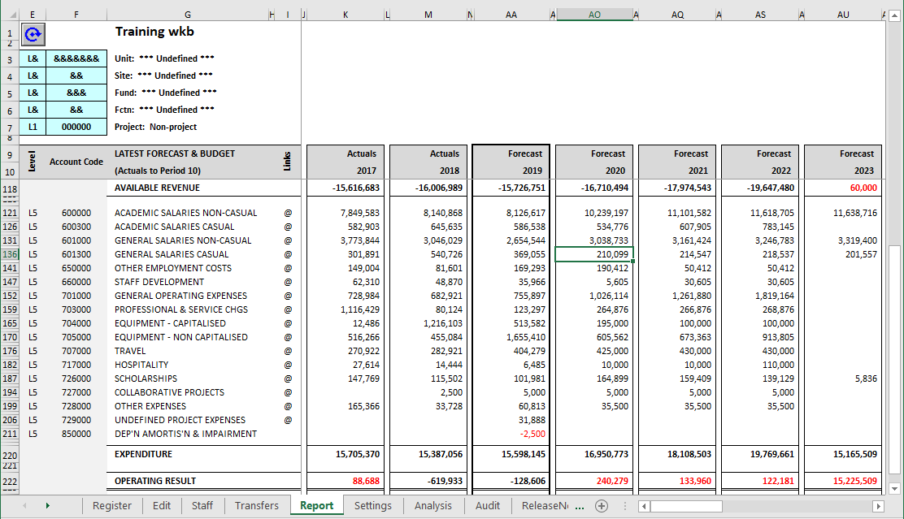

Variance Analysis:

The Report Tab can be used as a Variance Analysis Report. Different data sets can be selected for comparison against your latest forecast data stored in the Workbook (or against another data set). Year-On-Year Dollar ($) and/or Percentage (%) Change can be viewed easily when [Year On Year] Mode is chosen.

- [Report Mode] = [Comparison]
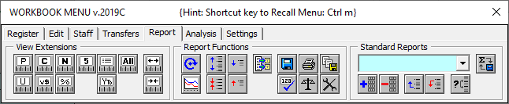
From the Workbook Menu > Report > Click to view [Report Mode] Col BE > Select [Comparison] from Drop-down Menu:

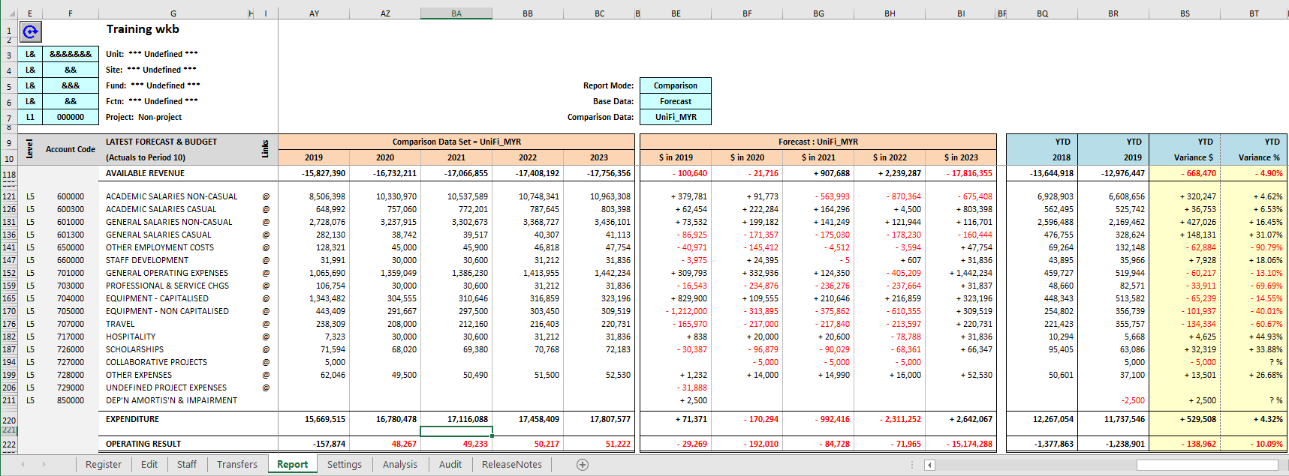

Examples:
Comparison of Forecast vs Mid-Year-Review data set:

Comparison of Forecast vs Original Budget data set:

Comparison of Forecast vs Full-Year_Review data set:

- [Report Mode] = [Year On Year]

Note: Other [Year-On-Year] Trend Reports can be viewed for different datasets by simply changing the [Base Data:]

SOME OTHER SPECIAL SETTINGS:

Fund Code

You can report on fund using four different levels or groups. The levels and corresponding codes are as follow (please refer to the Chart_Of_Accounts for any updates and changes):

Summary | Major Group  L1 | Minor Group  L2 | Detail Fund Code  L3
&&&&&& | 001  OPERATING | 100  General Operating | 100, 101, 102, 103, 104, 105, 106, 107, 109, 110, 113, 130, 133, 134, 137, 145, 146, 149, 156, 231, 508, 516, 682
 |  | 126  University Overheads | 126
 |  | 200  Internal Schemes | 123, 131, 135, 200, 201, 203, 204, 205, 206, 207, 208, 209, 210, 211, 212, 215, 216, 217, 218, 219, 220, 221, 224, 225, 227, 261, 263, 296, 297, 298, 299, 465
 |  | 250  Other Operating | 250, 251, 252, 602, 603, 604, 606, 607, 631
 | 002  RESTRICTED | 240  Consultancy | 240, 241
 |  | 300  Corpus | 300, 301, 302, 304, 305, 306, 307, 308, 309, 310, 311, 312
 |  | 400  Research Projects | 400, 411, 413, 414, 415, 418, 420, 423, 424, 426, 427, 428, 429, 430, 432, 433, 434, 440, 441, 442, 443, 444, 445, 447, 448, 450, 452, 455, 458, 459, 460, 461, 462, 463, 466, 469, 470, 471, 472, 473, 474, 475, 476, 477, 478, 479, 480, 481, 483, 486, 506
 |  | 500  Scholarships | 500, 502, 503, 512, 513, 520, 525, 526, 527, 529, 530, 541, 542, 543, 544, 545, 546, 547, 548
 |  | 600  Other Restricted | 128, 147, 150, 151, 152, 154, 155, 467, 484, 600, 601, 605, 608, 609, 611, 621, 622, 623, 931
 | 004  CAPITAL PROJECTS | 800  Capital Projs | 230, 232, 233, 234, 235, 283
 | 005  CORPORATE | 990  Corporate Summary | 982, 983, 985, 991, 998, 999

