Managing the MRF Report Settings.

Standard Reports can be accessed and managed from the Report tab.

The List of Standard Reports can be sorted using the up and down buttons to move any report up or down.

To Delete a Standard Report from the List, first select the report from the drop-down menu follow by clicking on delete report button.

To Add a new report to the Standard Reports List please do the following:
- Choose the type of Report required using the [Report Level Settings];
- Click to refresh the Report Tab;
- Click to Add the newly created report;
- Enter the Report Name and Click OK;
- Sort the Order by clicking either or .

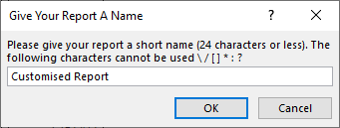

To produce ALL the reports from the Standard Reports list, Click on Bulk Report creation. This will automatically create a report for each tab from the list:

The Report will be saved on the same directory where the Workbook is saved with the following naming convention:

- Workbook_Unit_Name_Std_Reports_(yyyymmdd-hhmm).xlsx

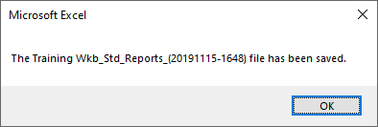
Eg. Training_Wkb_Std_Reports_(20191115-1648).xlsx

Example of Standard Reports:

