Staff Plan – Links
Once you have reviewed the data on your staff plan and made any required changes you need to update the Forecast / Budget data calculated per the Staff Plan into the Forecast data set in the workbook. In order to do this your Staff Plan records must all be linked to the Forecast data set.

OK means that the record is linked to the Forecast data set.
A cross means the record isn’t currently linked – If a Staff Plan record is not linked then the forecast costs for that position and any changes made will not flow through to your Forecast data set when you update the links

Creating Links
Most of the links should have already been set up when you receive your Workbook from your administrator. If there are any unlinked records on the Staff Plan there are two methods of setting up these links.

Automatic Linking

  - Audit Links
Select the “Audit Links” button. This will create links for the chartstrings used on the staff plan to the Forecast data set. The following prompts will appear

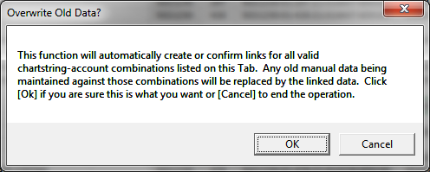

Clicking “OK” will establish the links between the staff plan and your forecast data set.

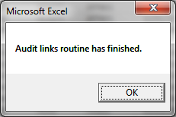

Click “OK” to return to the Staff Plan tab. The process should have set up links to all the records on the Staff Plan.

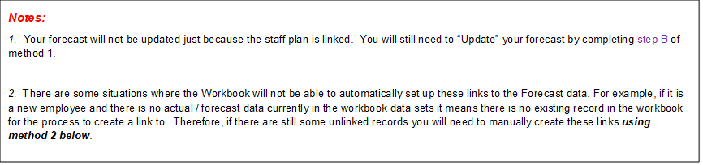

  - Updating Links (Refreshing Forecast)

On the Staff tab select the “Update Linked Accounts” button to update linked accounts.

This updates the forecast and future budget projections for all accounts & chartstrings linked to the Staff Plan.

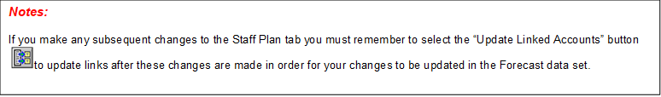

Linking one Chartstring at a time

You have the ability to link 1 chartstring at a time by using the “Link Chartstring” button .

This process will not only link a single chartstring but it will also link a chartstring that is unable to be linked through the automatic method.

To do this:

Ensure on your staff plan you have selected a row that contains the chartstring you want to link.
Click the “Link Chartstring” button:

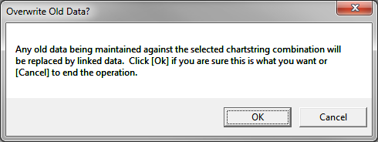

This creates a link between the staff line and forecast data set for this chartstring.

Either click on to view the changes for this chartstring on the Edit tab, so you can save these changes to the forecast data set. Or alternatively click on to push ALL changes to the forecast data set.

Ensure that you also save the entire workbook to keep all the changes.

