Staff Plan – General Guide
The "Staff" tab consists of data that is drawn from Aurion through Business Objects plus information/alterations that you might want to make to enhance the basic data. The downloaded components of the '"Staff" tab from Business Objects are:

- Current appointment details;
- Centrally funded leave that will occur in the current year;
- Superable and NonSupearable Allowances payable to staff that will be attributed to your cost centre;

It is important that you actually check each of the entries on your staff plan to ensure that it makes sense.

The Workbook Menu contains tasks specific function buttons (grouped as sheet specific functions) under each tab. The Staff Plan Functions have been developed to assist with managing the Staff Plan tab.

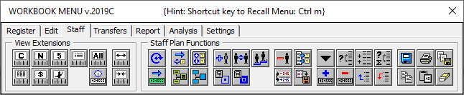

Sorting
Staff tab generally contains much information and sorting Staff data will enable clearer understanding of salary expenditure.
The Sort function uses Excel built-in Sort functionality. Additional columns can be added or deleted. Although staff tab has headings these cannot be used as part of the sort routine.
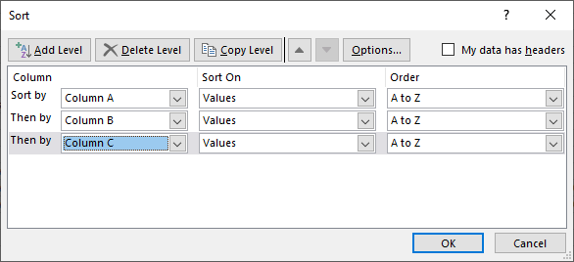

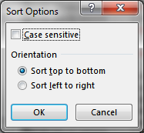

Note: Only sort top to bottom and NOT left to right.
Do NOT select headers!

Line breaks can be inserted after each change in the chosen column number for the entire staff plan.

Alternatively individual blank line can be added or deleted by clicking or from the Workbook Menu.

Sub-Totals
Excel Filters can be used to view subtotals:

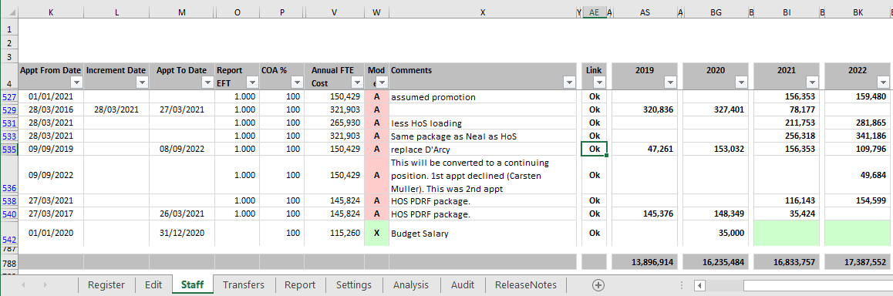

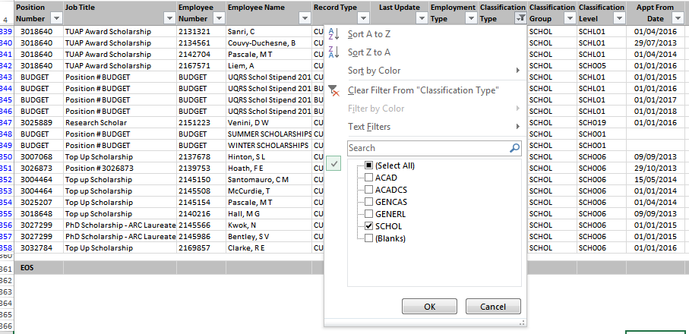
Blue colour row numbers signify filter is on.

To Reset and restore ALL filters, simply click on from the Workbook Menu:

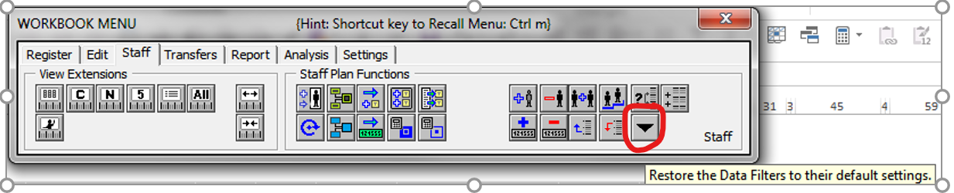

Editing / Adding Staff Records
The Staff tab is a planning tool for managing your Forecast & Budget staff costs. You can enter Budget positions if required for a new position or to consolidate a number of casual appointments into a single generic budget position.

Adds a blank costing line to the Staff Plan. You then need to enter the details for the new record.

Deletes the selected line from the Staff Plan. Deleted lines cannot be restored / undone so if you do this and want to restore the record you will need to add a new line and enter the details.

TIP – Select multiple rows at a time by highlighting all the rows you wish to modify in one go. For example deleting rows 6 to 9.

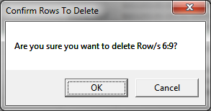

TIP – if another employee has similar details to a record you want to add (or you are adding another costing line for an existing employee) a quick way to add this is to select the duplicate position button- this copies the row you have selected and then you can go in and change any details on the newly created line.

Note - To allow for loadings and allowances (like HoS or First Aid) that expire on the system but still need to be modelled forward - duplicate the costing line and change the appointment start / end dates to Budget the costing into the future.

Increments the selected line manually by creating a new costing line with the employee being paid at the next step on the pay scale from the increment date - staff record to be incremented must have an increment date (in Col L) for this process to work.

When you add / change something on the Staff Plan you can record the reason in Col-X "Comments" and/or Col-Z “User Ref” as a reminder as to why you made the entry. If this column is hidden select to reveal.

Consolidating Staff Records
Generally Consolidation of Staff records is run as part of the Update DLDAurion routine. You can manually run this at any time by clicking on from the Workbook Menu. In order to find any matching records the Staff Plan is first sorted follow by validation for matches. A record is considered to be a DUPLICATE if the data in the shaded fields in the below table match exactly with another record:
COL | FIELD | RETAIN
A | Current Position Number
B | Budget Position Number
C | Job Title | Old
D | Job Type | Old
E | Employee Number
F | Employee Name
G | Record Type | Old
H | Last Update
I | Employment Type
J | Classification Type
K | Classification Group
L | Classification Level
M | Appt From Date
N | Increment Date | New
O | Appt To Date
P | Index CS Level 1
Q | Report EFT
R | COA %
S | Annual Salary Rate
T | Superable Allowances
U | NonSuper Allowances
V | RECL Liability | New
W | Full On-cost Rate
X | Model | Old
Z | Comments | Old
AB | User Reference | Old

Merge Staff Records
This function is designed to MERGE LIKE (but not Identical) records. This routine involves sorting the Staff Plan first before validation for matches between one Staff record with the next. You can manually run this at any time by clicking on from the Workbook Menu. Merging can be done either as AUTOMATICALLY or MANUALLY through a series of decision prompts to which the Users chooses to retain OLD or NEW record.

There are two different types of MERGER:
- GENERIC PARTIAL MATCH
- INCREMENT MATCH.

The latter assumes that the appointee has incremented and this essentially explains the difference between the OLD and NEW records.

The two situations are tabled separately below:

GENERIC PARTIAL MATCH

COL | FIELD | MATCH CONDITIONS | AUTO SELECTION | MANUAL
 |  |  |  | REVIEW
A | Current Position Number | Match OR Old = “BUDGET” | New | New
B | Budget Position Number | Match OR Old = “BUDGET” | New | New
C | Job Title | <=> | Old | User Selects
D | Job Type | <=> | Old | User Selects
E | Employee Number | Match OR Old = “BUDGET” | New | New
F | Employee Name | <=> | New | New
G | Record Type | <=> | New | New
H | Last Update | Old < New | New | New
I | Employment Type | Match | = | =
J | Classification Type | <=> | New | New
K | Classification Group | <=> | New | New
L | Classification Level | Match | = | =
M | Appt From Date | Match | = | =
N | Increment Date | <=> | New | New
O | Appt To Date | Match | = | =
P | Index CS Level 1 | Match | = | =
Q | Report EFT | Match | = | =
R | COA % | Match | = | =
S | Annual Salary Rate | <=> | New | User Selects
T | Superable Allowances | <=> | New | User Selects
U | NonSuper Allowances | <=> | New | User Selects
V | RECL Liability | <=> | New | New
W | Full On-cost Rate | <=> | New | User Selects
X | Model | <=> | New | User Selects
Z | Comments | <=> | Old | Old
AB | User Reference | <=> | Old | Old

INCREMENT MATCH

FIELD | MATCH CONDITIONS | AUTO SELECTION | MANUAL
 |  |  | REVIEW
Current Position Number | Match | = | =
Budget Position Number | Match | = | =
Job Title | <=> | New | User Selects
Job Type | <=> | New | User Selects
Employee Number | Match | = | =
Employee Name | <=> | New | User Selects
Record Type | <=> | New | New
Last Update | Old < New | New | New
Employment Type | Match | = | =
Classification Type | Match | = | =
Classification Group | Match | = | =
Classification Level | Old + Increment = New | New | New
Appt From Date | Match | = | =
Increment Date | <=> | New | New
Appt To Date | Match | = | =
Index CS Level 1 | Match | = | =
Report EFT | Match | = | =
COA % | Match | = | =
Annual Salary Rate | <=> | New | New
Superable Allowances | Match | = | =
NonSuper Allowances | Match | = | =
RECL Liability | <=> | New | New
Full On-cost Rate | <=> | New | User Selects
Model | <=> | Old | Old
Comments | <=> | Old | Old
User Reference | <=> | Old | Old

MANAGING THE STAFF PLAN / SPREADS

The "Staff" tab consists of data that is drawn from Aurion through Business Objects plus information/alterations that you might want to add to enhance the basic data.

Updating Links
Once you have reviewed the data on your staff plan and made any required changes you need to update the Forecast / Budget data calculated per the Staff tab into the Forecast data set in the workbook. In order to do this your Staff tab records must all be linked to the Forecast data set.

See QRG Staff Tab – Linking.docx for this process.

Reviewing the Staff Plan

It is important that you actually check each of the entries on your staff plan to ensure that it makes sense.

When reviewing the Staff Plan it may seem that some entries appear to be doubling up after an update – when the Staff Plan is updated the workbook will compare entries and delete any duplicate entries (ie. consolidation routine). However, if any position details have been updated in Aurion in between updates, e.g. appointment dates, class levels etc. the records won’t match and the workbook will retain both entries for a position. This means you will have to review the entries, decide which one is correct and delete the other entry using.

TIP – When comparing entries you can use the ‘Last Update’ date in Col.F to determine when the entry was added to the Staff Plan. In general you would expect the latest entry from Aurion to be the one you keep as this reflects an employee’s latest information in Aurion.

Extending Positions/Allowances
When reviewing the Staff Plan be aware that some records may have ‘end’ dates in Aurion that will be downloaded into your Staff Plan. If a position has an ‘Appoint to Date’ (in Col M) the Staff Plan will only forecast / calculate costs for that position up to that ‘Appoint to Date’.

This is most commonly found for allowances & loadings and also Fixed Term contracts. To extend these positions so they are fully costed in your forecast the best way is to duplicate the costing line usingand then change the appointment start and end dates to continue the costing. (Note by changing criteria such as appointment start/end dates will trigger a recalculation of that staff line. Otherwise to recalculate the row click onfrom the Workbook Menu after you have updated the start / end dates).

Budget / New Positions:

You can enter new positions / records into the Staff Plan if you think that they are required. E.g. you may need to add in a new employee or may want to consolidate a number of casual appointments into a single generic budget position to make it easier to model / forecast their costs.

Add a blank costing line to the Staff Plan. You then need to enter the details for the new record.

TIP - if another employee has similar details to a record you want to add, a quick way to add this is to select the duplicate position button this copies the row you have selected and then you can go in and change any details on the newly created line.

SPREADS:

On the Staff Plan the forecast / budget salary costs can be spread in a number of ways. This is determined by the value in the “Model” column (Col. W).

The forecast costs will be spread according to the appointment start and end dates based on the pay schedule when the line / worksheet is calculated.

The total cost entered for a year will be spread across the full year according to the standard spread table established for the natural account. You will need to manually enter annual totals in Cols AS, BG, BI, BK and BM.

You will need to manually enter monthly amounts in each period for the current and next budget year. These will then be aggregated on the worksheet to provide annual totals for these two years. Further to this, you will need to manually add annual totals for the last three budget years (Cols 61/BI, 63/BK and 65/BM).
(Note Model = T referencing Sub-Total, ie. Clicking will create subtotal rows with Model “T”.).

