Exporting Forecast data from the Workbook into the Reportal.
Once forecast changes have been made in the Workbook these forecast data will need to be uploaded into the Reportal. This can be completed by executing the following two processes (in this order):

- “End of Month Update” routine needs to be run to download the Last Period Actuals (LAP) into the Workbook (please refer to Appendix below or QRG for guidance); and

- “Standard Export” routine is then executed to upload Workbook data into the Reportal.

Note – The End of Month Update process is only required to be run ONCE a month to bring in prior month actuals in the workbook. This process does NOT need to be run each time a load is undertaken.

Standard Export

This process will create data files from the Workbook to be used for uploading into the Reportal.

Note – The Export button can be found on the Settings and Edit tabs. Exporting from the Settings tab will export ALL data from the Workbook whereas Exporting from the Edit tab will upload data specific to the displayed chartstring.

Please ensure all steps in this process are followed in order to achieve a successful load:

- Update All Links. This routine ensure that all links from the Staff Plan and Transfers tab are updated accordingly with any changes made in the Workbook.

- Select the Export Scenario to which the Workbook data are to be exported to. Selection can be done from the Settings tab (GREEN highlighted drop down box under column A).

Export Scenarios for selection include:
  - CUR = Current (will also update MyBalance Project reports)
  - MYR = Mid-Year Review
  - BUD = Budget
  - FYR = Full-Year Review

- Upload the forecasts into the Reportal.
    - Click on the Standard Export button. This runs a process that produces five {.tab} extension data files from the workbook which are then saved on a shared directory (administered by FPA) ready for loading. The data files include forecast (FOR), plan (PLN), staff plan (STF), transfers (TRF) and BAT. The latter file contains information such as chartstring details, LAP, Workbook version along with scenario information directing the Reportal where to load these data sources.

Examples of export files:

Application to this directory can be done through FPA (fpa@fbs.uq.edu.au).

    - A message box displaying progress will appear. Depending on the size of the files it generally should take only a few minutes for this routine to complete. Data Warehouse runs a process every minute to pick up these data files on the shared drive and queue them for loading into the Reportal.
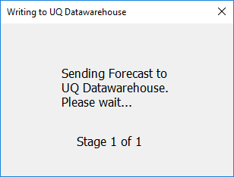

    - Upon completion of the load an email will be sent to your outlook inbox detailing the status of the load. Any Unsuccessful Load will require for the error to be rectified before re-loading.
Successful Load Example:

.

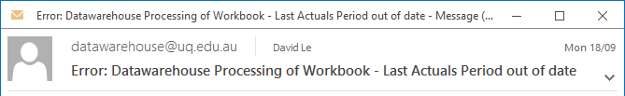
Unsuccessful Load Example: The Last Actual Period is Out of Date and suggests that the End of Month Workbook Update will need to be executed before the export routine is processed again.

Note the Export process can be processed as often as required daily. The Data Warehouse routine cuts off at 10.30 pm daily and restarts at 6.30 am the following day. Any export done between these hours will be queued for processing at 6.30 am the following morning.
- Generate a Business Object Report (eg. Multi Year Forecast) in the Reportal and check that it matches back the Workbook. Any issue please contact FPA for assistances.

Appendix A
Loading Errors

- The last completed actuals period (LAP) on the settings tab is incorrect. As the actuals replace the forecast each month in the forecast metric, the forecast should only replace future periods. If the last completed period is incorrect it is most likely due to the DLDUnifi file not having been run to bring in the last months actuals.

Solution: Run the End of Month Update process (ie. DLDUniFi File) and then re-run the Export routine.

- The forecast scenario is incorrect. Forecasts should only be loaded into the active forecast scenario. Check the settings tab that the scenario is the active scenario.

Solution: Change the scenario on the settings tab to the active scenario and then select the export button

Appendix B

Updating the Workbook with the Latest Actuals (ie. executing Forecast Download for UniFi process).

A. Login to Reportal: https://mis-xi4-web.mis.admin.uq.edu.au/BOE/BI

B. From the home page select “Finance”
C. Under Finance Choose:
- Workbook
- Forecast Download – UniFi (2019)
    - Report from right hand window panel
    - Note: Double click to run

D. When the report prompt appears select:

- Forecast scenario eg. CUR
- School / Division eg. Finance and Business Services
- Optional prompts:
    - Operational Group
    - Operational Unit
    - Fund Code & Descr
- Click “OK” at the bottom of the prompt window to execute

E. Save the report.
- Click on the “Export” button at the top
- Select “Reports”
- Select File Type as “Excel (.xlsx)” from Drop-down list
- Click “OK”

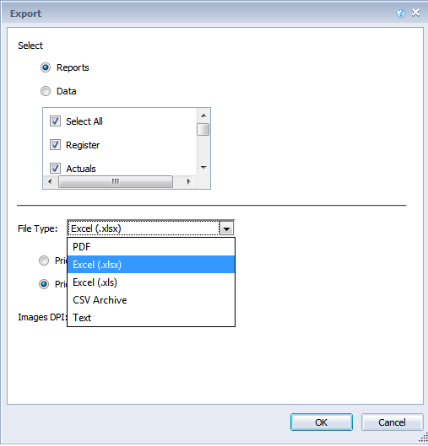

Save the file and name it: dldunifi.xlsx
It is not case sensitive

F. Open the dldunifi.xlsx file (if it is not already open).

It is recommended that you save the dldunifi.xlsx file in the same folder as your workbook.

- From the [Settings] tab in your workbook menu,
- Click the “Update from Unifi” button .

- Once done you will receive a “UniFi Update has finished” message box.
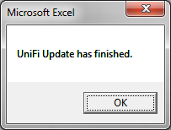
- Click OK.

