Entering Multi-Year Forecast Data into the Workbook.
Note – Multi-Year data entry will require Next Year’s data to be entered as monthly figures and each subsequent forecast years as annual totals. For example; if Next Year is 2020, we would need to enter the forecast data for 2020 by month and annual totals for 2021 to 2023.

On the ‘Edit’ worksheet –

- Select a chartstring to edit from the blue drop-down box in the top left hand corner of the worksheet.

- This will automatically load the Latest Forecast data for the selected chartstring.

TIP – You can also select a chartstring to edit from other tabs in the workbook by selecting the chartstring you want to edit and clicking- this will take you to the Edit tab and load the latest forecast data for that chartstring.

- Ensure future forecast years are displayed – if they are hidden on the worksheet clicking on from the Workbook Menu will unhide these data columns. Next Year data will need to be entered and phased by month. If the monthly columns are not shown, clicking on will toggle views between annual and monthly breakdown.

- The starting view for this worksheet is at the sub-total level (ie. L5 account level) – you cannot enter data at this level and will need to drill down to the next level (L6 account level) to enter data – the area where data entry is allowed is highlighted in light green.

Unhide data entry areas can be done either by:
- Unhide All rows by clicking
- Unhide One Row by selecting the row you want to edit and clicking
- Using or respectively will re-hide these rows to show only sub-total accounts again

TIP – You can also Double-click on the Rows under each Account Level on the Edit tab to drill down or up a level. Similarly, double-clicking on Period or annual column will show/hide month-on-month data.

- Enter the require forecasts and confirm each Full Year totals in columns AO, AQ, AS & AU are as expected before proceeding.

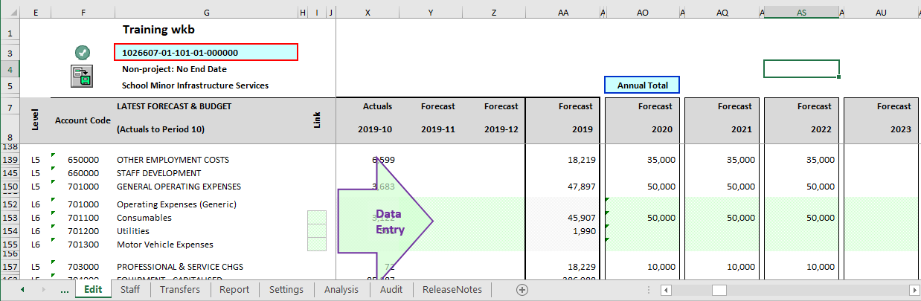

- You can enter Next Year forecast data by manually keying the data into the worksheet. This can be done in a month-on-month basis by selecting [By Month] as the Edit Mode on column AO;

- Alternatively Next Year forecast data can be entered directly into the annual total column (ie.as annual total amounts rather than monthly figures) by changing the Edit Mode to [Annual_Total]. This annual total will be spread across periods automatically based on the Spread Table.
Note: there still contain formulas in the annual column; just overwrite as this will trigger an event to readjust the monthly amount in accordance with the spread table.

- The ‘Edit’ tab on the Workbook Menu contain a group of Edit Function buttons. These buttons are designed to assist with updating the forecast data. There are two versions of the same button under each function; depicting either a single bar or multiple bars in the top corners – the number of bars indicate whether only the selected account line (one bar) or all account lines (multiple bars) will be adjusted.

- Project Forward Inflated:- Generates future annual forecasts (Yrs 2-5) allowing for inflation. Linked data can either be maintained or deleted. Default base is the current year forecast.
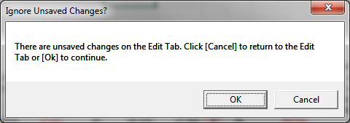
- Project Forward Flat Rate:- Generates future annual forecasts (Yrs 2-5) without allowing for inflation. Links can either be maintained or deleted. Default base is current year forecast.

Note: The workbook is in the general ledger format so income should be entered as a negative and expenses as a positive.

- Once you have entered your multi-year data, confirm the Full Year totals are as expected for the selected chartstring and proceed to post the forecasts by clicking the save forecast button from either the Workbook Menu or directly from the Edit sheet. This updates the Forecast for that displayed chartstring and stores the data in the workbook.

Note: CLICKING ‘POSTS’ THE FORECAST CHANGES TO YOUR WORKBOOK – HOWEVER, THIS DOESN’T ACTUALLY SAVE YOUR WORKBOOK FILE TO THE NETWORK.

In order to save the entire workbook, click file then Save or Clicking keys “Ctrl” & “S” together will save the file.

- Once the changes you have made are saved you can then move onto the next chartstring to work on.

Warning: If you don’t post the changes using before moving on and loading the next chartstring you will lose any forecast changes you have made. An amber traffic light indicator is displayed next to the CS, as well as a pop-up box warning that there are unsaved changes on the Edit tab.

