Entering Forecast Data into the Workbook.
On the ‘Edit‘ worksheet –

- Select a chartstring to edit from the blue drop-down box in the top left hand corner of the worksheet

- This will automatically load Latest Forecast data for the selected chartstring

TIP – You can also select a chartstring to edit from other tabs in the workbook by selecting the chartstring you want to edit and clicking, this will take you to the Edit tab and load the latest forecast data for that chartstring.

- To enter Forecasts you will need to have Periods 01 to Periods 12 unhidden for the current year - if they are hidden on the worksheet clicking on will unhide this data (or double-click on the Period Header).

- The starting view for this worksheet is at the sub-total level – you cannot enter data at this level and will need to drill down to the next level to enter data – the area where data entry is allowed is highlighted in green. Any YTD actuals for the chartstring will be locked and cannot be changed (and won’t be shaded green on the spreadsheet).

In order to unhide the data entry areas you can either:
- Unhide All rows by clicking
- Unhide One Row by selecting the account you want to edit and clicking
- Using or will re-hide these rows to show only sub-total accounts

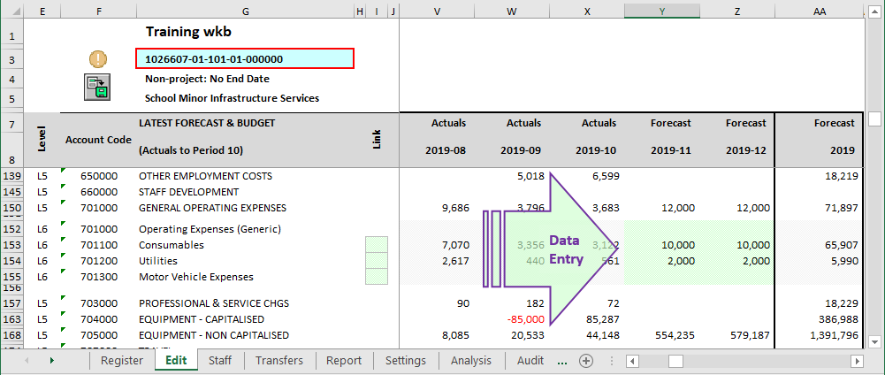
TIP – You can also double-click on the rows under each account level on the Edit tab to drill down or up a level.

- Enter any forecast changes for that chartstring as required and check the Full Year Forecast totals in column AA are as expected.

- You can enter forecast data by manually keying the data into the worksheet. The sub-totals will update automatically. You can also use the following buttons to help with updating the forecasts -

Adjust Remaining Forecast to Last_Submission_Period - This prompts the user with the adjustment required to make the full year forecast equal to the Last Submission Period forecast amount. The adjustment is all posted into the next forecast period post the Last Actual Period (LAP).
- Forecast in FYR will adjust to MYR Data Sets
- Forecast in MYR will adjust to BUD Data Sets
Adjust Remaining Forecast - This prompts the user to enter the amount they want to either increase or decrease the full year forecast by and then spreads the required change evenly over the remaining periods in the current forecast year.

Clear Forecast – This clears the forecast to zero for the remaining forecast periods and future years. It also gives the option of clicking “OK” to put an entry into the first forecast period to show any YTD actuals being reversed or clicking “Cancel” to just clear out the forecast periods.

Note: The workbook is in the general ledger format so income should be entered as a negative and expenses as a positive.

- Once the Full Year forecast totals are as expected for the chartstring you need to post the forecast changes made to the workbook by clicking. This updates the forecast for the chartstring and stores the data in the workbook. Successful save will trigger the traffic light indicator to a green tick.

Note: CLICKING ‘POSTS’ YOUR FORECAST CHANGES TO YOUR WORKBOOK – HOWEVER, THIS DOESN’T ACTUALLY SAVE YOUR EXCEL WORKBOOK TO THE NETWORK.

In order to save the workbook select “File -> Save” from the Excel toolbar or Simply Ctrl + S.
- Once the changes you have made are saved you can then move onto the next chartstring to work on.

Warning: If you don’t post the changes using before moving on and loading the next chartstring you will lose any forecast changes you have made. An amber traffic light indicator is shown next to the CS, as well as a pop-up box that there are unsaved changes on the Edit tab.

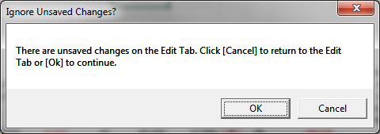
Variance Analysis Functions:

Variance Analysis columns are provided on columns AY onwards on the "Edit" tab to help with forecasting:

- Variance columns can be viewed by clicking on ;
- Clicking on will show Variance $ movement as well as Drop-down boxes for selecting the different Data Sets for comparisons;
- Clicking on will show Variance % movement;

You can change the data sets to compare by simply selecting alternatives from the drop down boxes in column BE (highlighted blue boxes).

- Selecting [Year On Year] will show movement between each consecutive years (ie. Trend Report) whereas choosing [Comparison] will allow further selection of different Data Sets ranging from UniFi, UniFi Quarterly Data Set to UniFi_OB (Original Budget) Data Sets.

