# **End-of-month Update.**

*This process will update the prior month actuals in your workbook and can be performed once PBI have advised actuals are available.*

*PBI usually ends an email advising actuals are available on the 3rd working day of the month.*

The end of month update process is performed by following the [Update] steps (below) accessible from the settings tab of your Workbook Menu.

The [Update] C:\DAVID\DAVID\1.Workbook\3. Dev\buttons\UpdateRegister.bmp button is to download data from UniFi whereas [Update] C:\David\1.Workbook\3. Dev\buttons\Set Up Staff Plan.bmp button is to download data from Aurion.

**Step 1 – Check settings are up-to-date and reflective of current period (settings tab of your workbook)**

Before executing the [Update] routine, check and ensure the following settings are reflective of the current period:

**Step 2 – Update from UniFi C:\DAVID\DAVID\1.Workbook\3. Dev\buttons\UpdateRegister.bmp (with Latest Actuals)**

**A.** Login to Reportal: [*https://mis-xi4-web.mis.admin.uq.edu.au/BOE/BI*](https://mis-xi4-web.mis.admin.uq.edu.au/BOE/BI)

**B.**  From the home page select “Finance”

**C.** Under Finance Choose:

* Workbook
* Forecast Download – UniFi (2023)

*Report from right hand window pane*

*Note: Double click to execute*

**D.** When the report prompt appears select:

* Forecast Scenario: *eg.* ***CUR*** *for current scenario*
* School / Division: *eg. Finance & Business Services*
* *Optional prompts:*
  + *Business Unit*
  + *Operational Group*
  + *Operational Unit Desc/Code*
  + *Fund Group*
  + *Fund Code & Descr*
* Once the prompts have been selected, Click “OK” at the Prompts box to execute

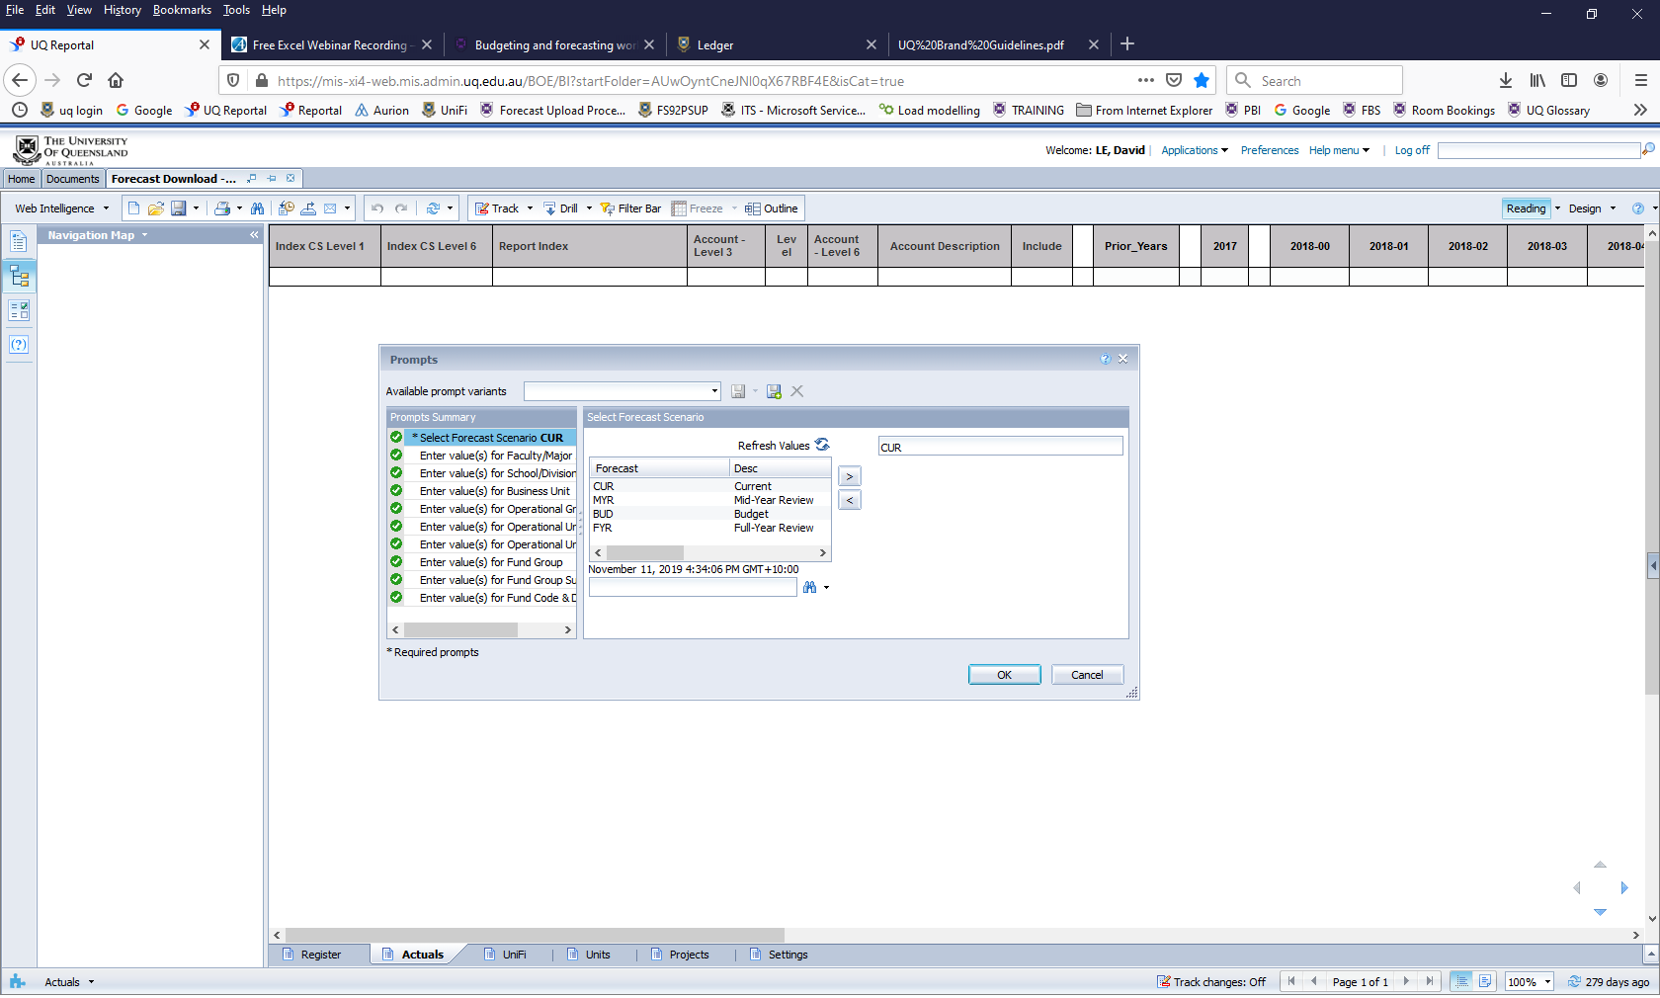

**E.** Save the report.

* *Click on the “Export” button at the top 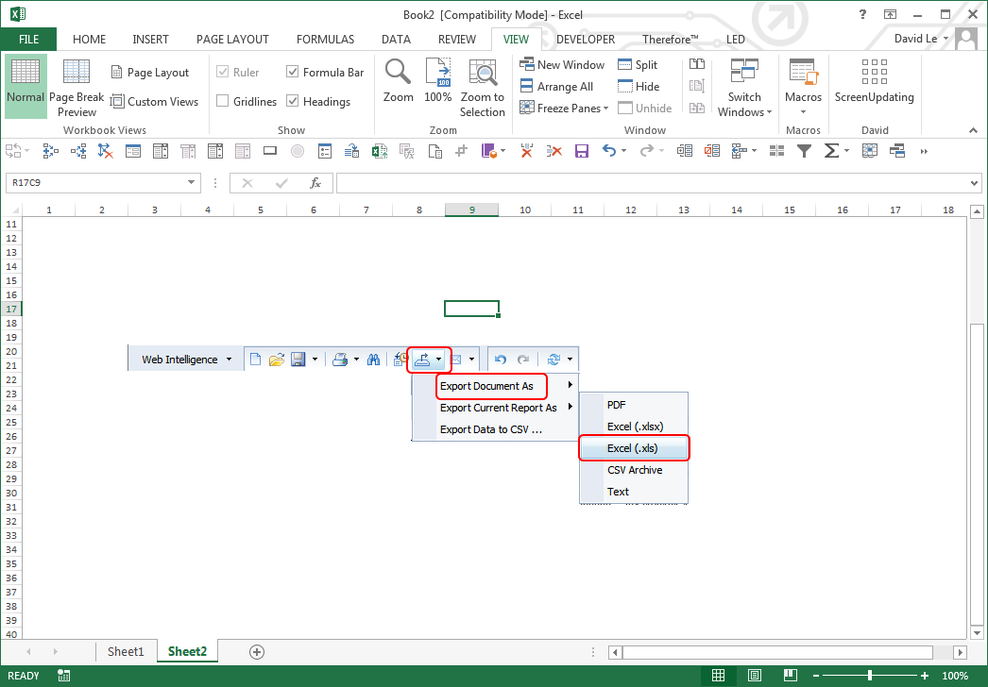*
* *Select “Reports”*
* *Select File Type as “Excel (.xlsx)” from Drop-down list*
* *Click “OK”*



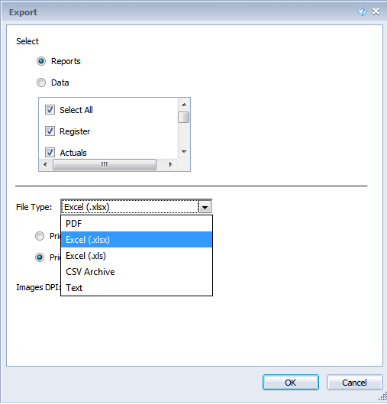

Save the file and name it: **dldunifi.xlsx**

*(It is not case sensitive)*

**It is advisable to save the download file on the same folder as your workbook.**

**F.** From the [Settings] tab in your workbook menu, click the “Update from the UniFi” button C:\DAVID\DAVID\1.Workbook\3. Dev\buttons\UpdateRegister.bmp **.**

Once done you will receive a “UniFi Update has finished” message box.

Click OK.

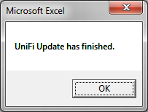

**G. Validate the Workbook to the UQ Reportal**

**Part 1: Workbook**

In the workbook, navigate to the “Report” tab and clear any filters from the green boxes in Column E, Rows 3 - 7 so that it looks like this:

The workbook needs to display the monthly view. If this is not shown click on  button from the Workbook Menu.

Click the refresh button:  to show the latest report information. It should look as below depending on what columns are displayed.

**What to check for:**

1. This part of the report tells you what period your actuals should be to.

2. This line differentiates where actuals stop and forecast figures begin.

3. This operating result should match the operating result in the UQ Reportal report.

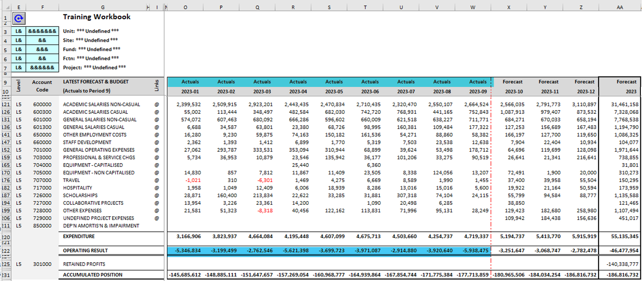

In this example, we have updated the workbook for Actuals for periods 1 to 9. These Actuals figures should match the operating result for periods 1 to 9 in the UQ Reportal (as below in Part 2).

**Part 2: UQ Reportal**

Run the Monthly Spread Report.

This can be found under “Finance”, then “Operational Reports” folder (as follow):

Double click the report name to bring up the report prompt.

There are two mandatory requirements:

1. Select Forecast Scenario:

*CUR = Current Scenario*

*MYR = Mid-Year Review Scenario*

*BUD = Budget*

*FYR = Full-Year Review*

2. Select Fiscal Year: *eg 2023*

All the other prompts are discretionary eg. Select School / Division(s)

*If you are unsure what scenario you should be selecting please contact FPA.*

Below is an output example of the Monthly Spread Report – Actuals Tab.

Now compare the results of the workbook and the UQ Reportal report. The workbook for periods 1 to 9 should match the Monthly Spread Report (as below).

*Please note the Reportal will show the Operating Result as Surplus/(Deficit) whereas the Workbook will display it as Debits and Credits.*

From Workbook

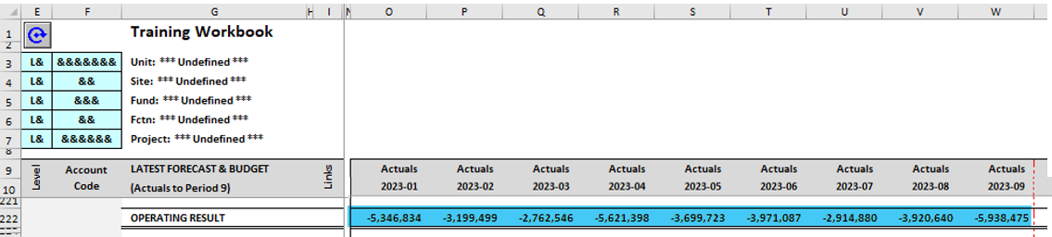

*This confirms that the update of the monthly actuals data in the workbook has been successful!*

**Step 3 – Update Staff Plan**

**Optional**



The staff plan update is optional. It depends on your units requirements and

staff movements.

**A.** Login to Reportal: *https://mis-xi4-web.mis.admin.uq.edu.au/BOE/BI*

**B.** From the home page select “Finance” and drill down to expand show “Workbook” directory

**C. Under Finance Choose:**

* Workbook
* Forecast Download – Aurion (2023)
  + *Report from right hand window pane*
  + *Note: Double click on the report name to run*

**D.** From the report prompts select:

* Official Employment Types

These will depend on your area and your needs however the most common would be: CONT, FIXED, SCHOL

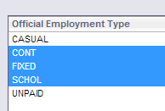

* Select your School
* Optional selection(s):
  + Operational Group, Unit Code/Name
  + Unifi Fund Code/Group
  + Include RecLeave Liability Amounts Greater than: *1000 (Default – leave or change as needed).*
* Click “Run Query” from the bottom of the prompt window.

**E.** Save the report.

* From the toolbar click on the “Export” icon
* Select “Reports”
* Select File Type as “Excel (.xlsx)” from Drop-down list
* Click “OK”

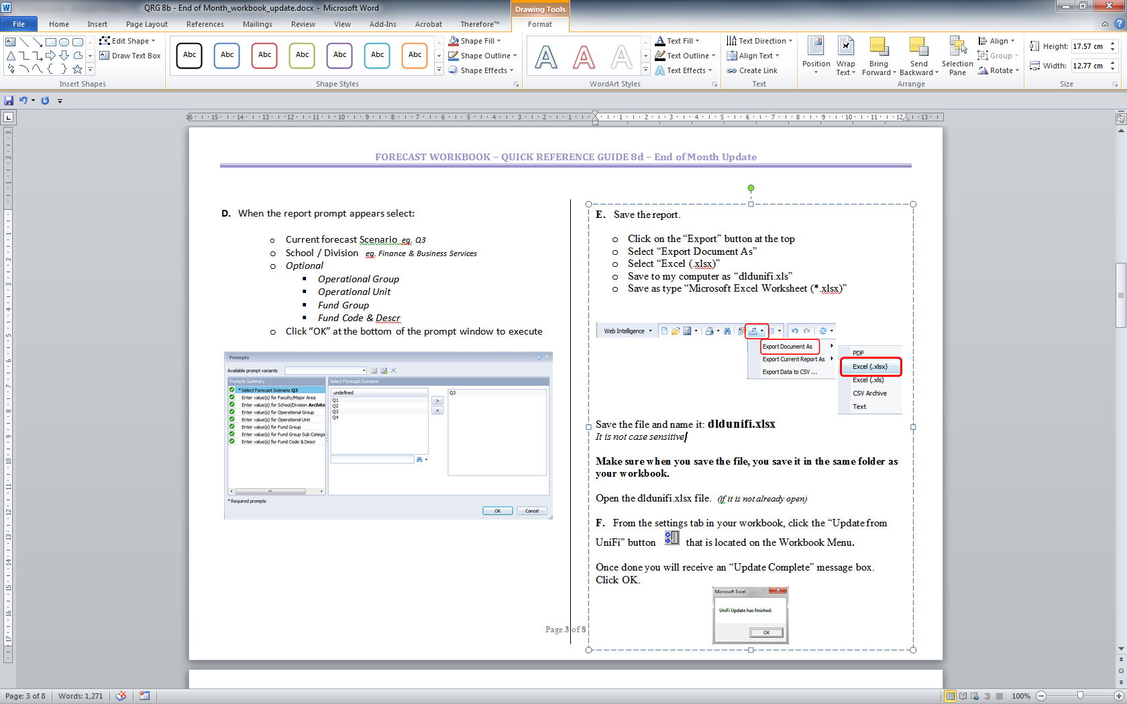

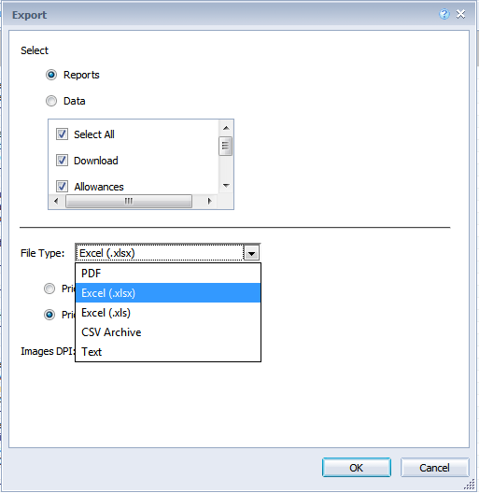

Save the file and name it: **dldaurion.xlsx**

*It is not case sensitive*

**Make sure when you save the file you save it on the same folder as your workbook.**

**F:** Open the dldaurion.xlsx file. *(if it is not already open)*

From the [Settings] tab on your workbook menu,

Click the [Update] Staff Plan button C:\DAVID\DAVID\1.Workbook\3. Dev\buttons\Set Up Staff Plan.bmp**.**

This will start the import process and will give you some prompts throughout. These prompts are.

1. Click [OK] to consolidate similar staff records.

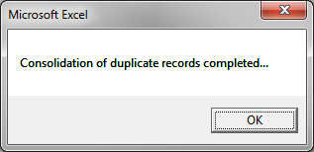

1. *(Cont’d)*

A record is considered to be a DUPLICATE if the data in the shaded fields in the below table match exactly with another record:



1. Click [Yes] if you want to match Job Titles from Aurion. Selecting [No] will preserve what is in the Workbook.

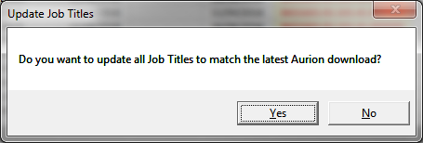

1. Click [Yes] if you want to match Job Types from Aurion. Selecting [No] will preserve what is in the Workbook.

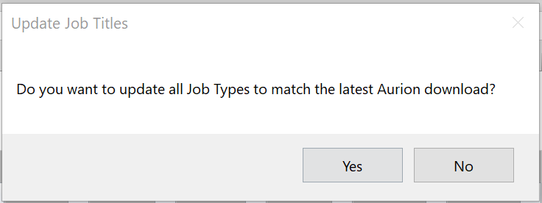

1. Click [Yes] if you want to update record type to “HISTORY” for old records that can no longer affect the future forecast. Click [No] to leave them as they are.

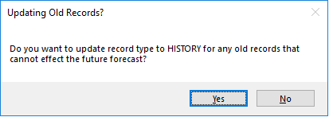

If you click **Yes** this will change record type to HISTORY for all records that have an appointment to date where the month is before the current month.

If you click **No** this will retain all data regardless of appointment to dates.

This concludes the Staff Plan Update process.

It is advisable to review your staff plan at this point. More information on managing the staff plan can be found at:

[*https://coo.uq.edu.au/operational-areas/finance/finance-staff/budgeting-forecasting-and-reporting/budgeting-and-forecasting-workbook*](https://coo.uq.edu.au/operational-areas/finance/finance-staff/budgeting-forecasting-and-reporting/budgeting-and-forecasting-workbook).