# **New Workbook creation for a Group of Chartstrings.**

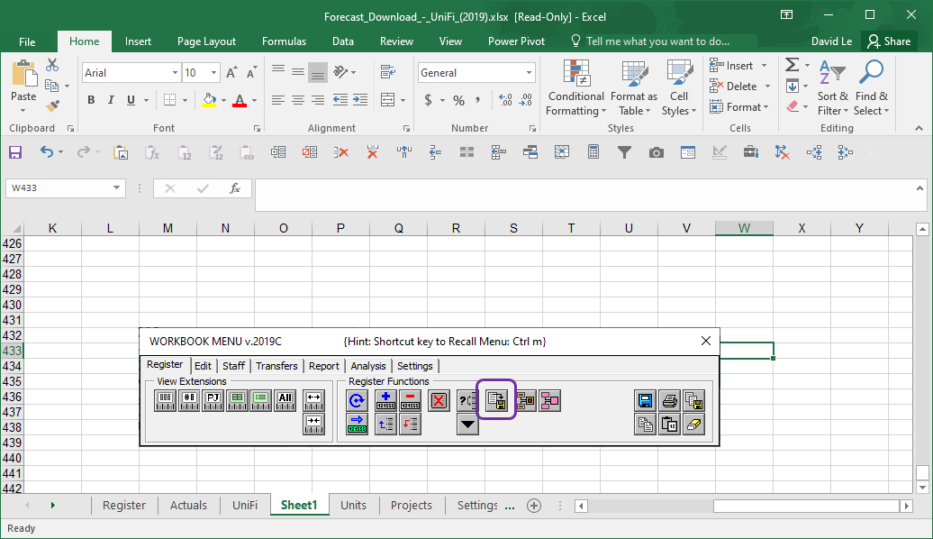

This functionality is developed to allow creation of a new workbook from a group of chartstrings listed on the Register tab. This is useful where a current and established workbook requires to be split into smaller manageable workbooks.

**Step 1: Group Report CODE**

A Unique Group Report CODE is inserted in User Reference (Col AN) for each chartstring which requires to be moved onto the NEW workbook:

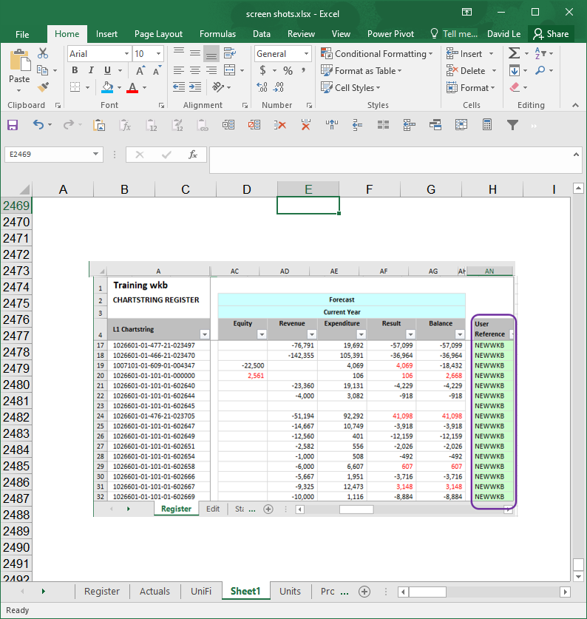

**Step 2: Create Group Workbook:**

Click on cid:image004.png@01D2F592.BA67C980 Create Group Workbook button to kick off the routine. This will trigger a textbox requesting the Report Code:

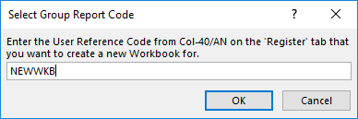

The routine will create a new workbook containing ONLY the list of chartstrings with the Group Report Code.

The Original workbook will remain unchanged for reference.

Forecast, Actuals and UniFi datasets for this list will be copied into the new workbook.

Staff plan containing this list of chartstring will be copied over.

Any transactions on the Transfers tab will be replicated on the new workbook.

***Note*** *transactions with OAR calculations will be replaced by values preventing linkage back to the original workbook. Please check and S:\Management Accounting Group\Budget & Forecast Workbook\Workbook 2016 Development\Buttons\Refresh.bmp refresh to insert formula.*

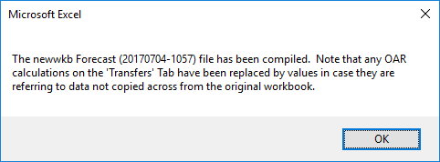

The new workbook will be saved as:

* GroupReportCode_Forecast (YYYYMMDD-HHMM).*xlsm* on the same directory as the original workbook.