**Workbook Summary Guide**

**Step 1. Report Tab**

When you get your updated workbook go to the ‘Report’ tab and run the report for your whole school / unit.

1. To view your whole school / unit leave all the blue shaded boxes blank (or reset them to show [L&] as below).
2. Click on the Refresh button to run the report.

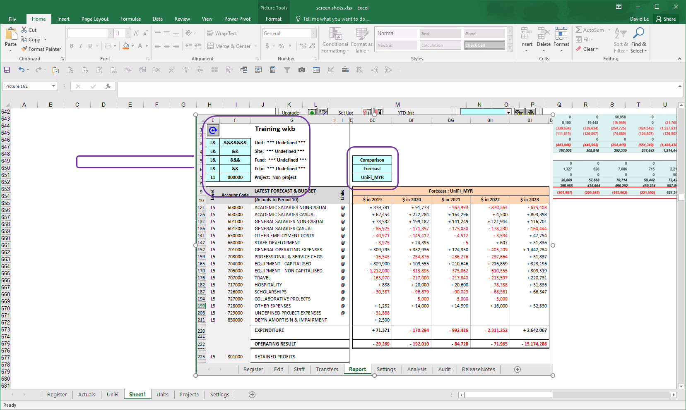

Once the report has run check the data for any obvious discrepancies to see the current position of your business unit against the previous forecast [UniFi_???], Budget [UniFi_OB] and prior years [Actuals] – by selecting the different data sets for viewing from the [Variance Data Set] drop down box above. If you have any predetermined ways to view your data, e.g. by fund group, you could also look at these.

Example: Comparing Workbook Forecast Vs MYR (ie.Mid-Year Review).

*Select* [Report Mode] = **Comparison**

>> [Base Data] = **Forecast**

>> [Comparison Data] = **UniFi_MYR**

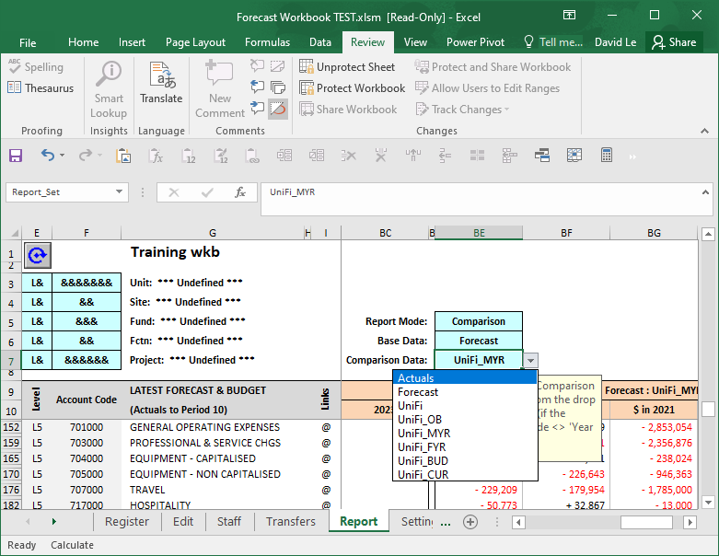

Example: Original Budget Dataset Vs MYR.

*Select* [Report Mode] = **Comparison**

>> [Base Data] = **UniFi_BUD**

>> [Comparison Data] = **UniFi_MYR**

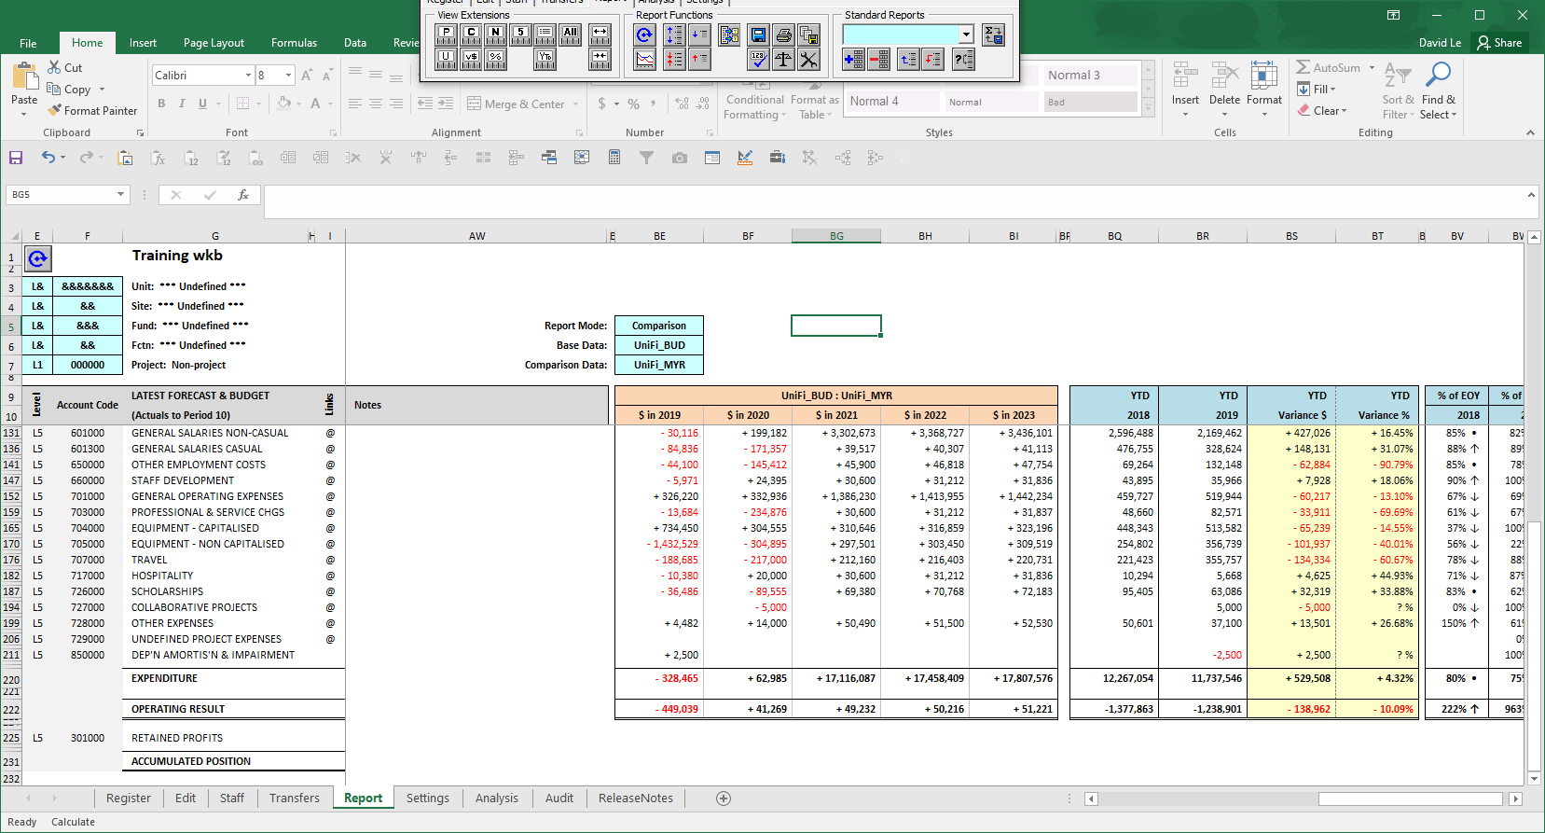

Example: Viewing Year-On-Year Workbook Forecast Trend Report.

*Select* [Report Mode] = **Year On Year** >> [Base Data] = **Forecast**

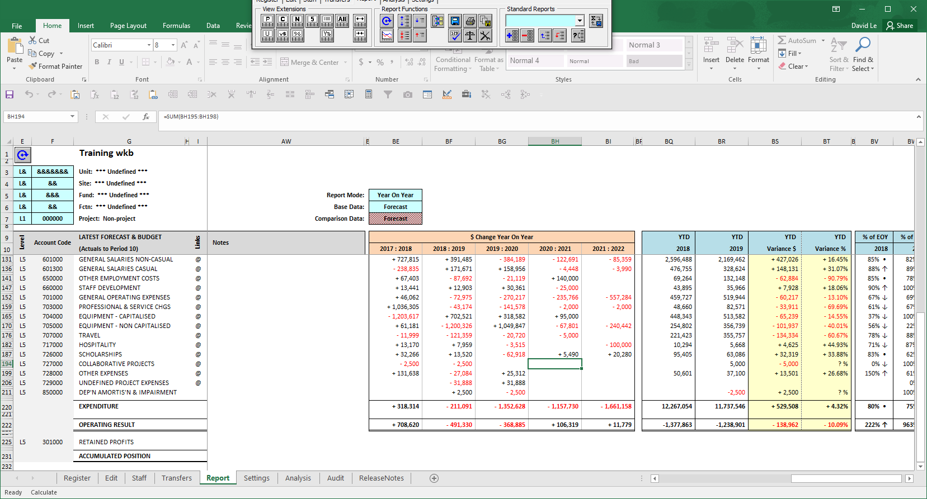

**Step 2. Review Staff Plan.**

1. Check the employees are calculating correctly. You can sort the staff plan by employee, chartstring *etc* by clicking on custom sort C:\DAVID\DAVID\1.Workbook\3. Dev\buttons\Custom Sort.bmp from the Workbook Menu. You can use filter/s to group staffs into Classification Groups and /or levels for analysis.
2. If you know of any new positions in the pipeline or an employee is missing you can add a new line by clickingand populating the relevant information.
3. If you need to remove any positions from the staff plan you can delete them by selecting the row and clicking.

 **TIP** – If an employee is on a fixed term contract and you need to extend the end date to make sure the position is correctly reflected in your forecast. The best way to do this is to select the employee and click  to duplicate position. This inserts a copy of the employee record in the row below – you can then go and change the start and end dates to extend the position in your forecast for as long as required.

1. Changing each condition/criteria *(eg. Start or End dates, Classification Level)* on a staff line **automatically** triggers a recalculation.

You can also recalculate the entire Staff Plan to ensure that all adjustments have been calculated – this is done by clicking.

Alternatively you can just recalculate for the one line by clicking CalcOne - this will calculate just the row that you have selected.

1. Next you need to ensure all your staff plan entries are linked to the Forecast data set – column AE shows whether an employee record is linked or not.

 - Employee record is linked to your Forecast data set

 - Employee record is NOTlinked your Forecast data set

Most of the records should already be linked when you first go to the workbook. If you have any unlinked records see *Quick Reference Guide – “Staff Plan – linking the staff plan***”** on how to create links on the staff plan.

1. When all adjustments have been made and all employee records are linked you need to ‘push’ the staff plan data into the forecast data set. On the Staff Plan tab click on button to update all linked account rows. It is best practise to save your workbook (regularly) to retain changes made.
2. Check and refresh (if needed) the [Report] tab Refresh.bmp to load the updated Forecast data and ensure that you understand the changes made before proceeding.

**Note -** The update links process will update the latest forecast and future budget projections for all accounts linked to the Staff Plan. If there are any subsequent changes made on the Staff Plan tab you need to update the links each time in order to get these changes updated in your Forecast projections.

**Step 3. Register Tab**

The [Register] tab is used to maintain a list of all of the unique chartstring combinations used in your School / Unit.

The [Register] tab can also be used as a basic reporting / management tool to show you Level 3 account balance information for your forecast data set for each generic chartstring combination. This can be a quick way of identifying and verifying forecast movement across all of your chartstrings.

This list is updated in the End of Month update process to pick up any new chartstrings. If required users can also Add or Delete chartstrings to the [Register] themselves, e.g. for a new project planned to commence in the future but the chartstring hasn’t been picked up in the End of Month update process as there is currently no GL activity for it.

 Click to Add a Chartstring (and then follow prompts)

 Click to Delete a Chartstring (**Note –** User Status & Check Status must both be flagged “**X**” in order for a delete to be allowed).

**TIP** – You can select a chartstring to edit from the [REGISTER] list by selecting the chartstring you want to edit and clicking- this will take you to the [EDIT] tab and load the latest forecast data for that chartstring.

**Step 4 – Edit Tab**

This is where you can call up and edit the forecast / budget for each generic chartstring owned by your organisational unit in a simple I & E (Income and Expenditure) statement format. Other tabs, for example, the Staff Plan can be 'linked' to this worksheet to simplify the provision of complex future forecast figures. Changes made on this tab are saved to the [Forecast] data set in the workbook.

1. Select a Chartstring to Edit from the green drop down box in the top left hand corner of the worksheet and then click on the refresh buttonRefresh.bmp to load the Latest Forecast data into the worksheet.

1. On the [Edit] tab you can enter data at the detail level into cells that are highlighted green - other areas in the worksheet, e.g. YTD Actuals, headings and sub-totals, are protected and cannot be changed. If you can’t see any data entry areas when you first go into the workbook you may need to unhide these using the following buttons:

 Unhide one row (Reveals only the row you have currently selected)

 Unhide All Rows

 **TIP** – You can Show/Hide any account group by double-clicking to drill up or down a level. *Eg. Double-clicking L5 major account group will drill down to L6 minor account group.*

Similarly, double-clicking on any Annual header will display the associated Periods for that year. Vice-versa, double-clicking on any Period header will hide all the corresponding period and display annual header only.

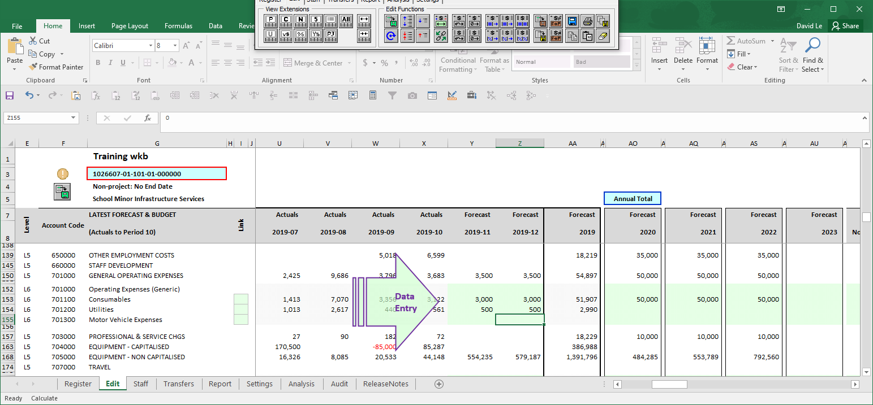

1. Enter any forecast changes for that chartstring as required and check the Full Year Forecast totals (in column AA) are as expected.

**NOTE: -** **The workbook is in the general ledger format so income should be entered as a negative and expenses as a positive.**

1. Once the Full Year Forecast totals are as expected for the chartstring you need to post the forecast changes made to the workbook by clicking. This updates the latest forecast for that chartstring and stores the data in the workbook.

**NOTE: - CLICKING ‘POSTS’ YOUR FORECAST CHANGES TO YOUR WORKBOOK – HOWEVER, THIS DOESN’T ACTUALLY SAVE YOUR EXCEL WORKBOOK TO THE NETWORK.**

**In order to save the workbook select “File -> Save” from the Excel toolbar.**

1. Once the changes you have made are saved you can then move onto the next chartstring to work on.

**WARNING: -** **If you don’t commit the changes using** **before moving on and loading the next chartstring there is a reminder message and you will lose any forecast changes you have made.**

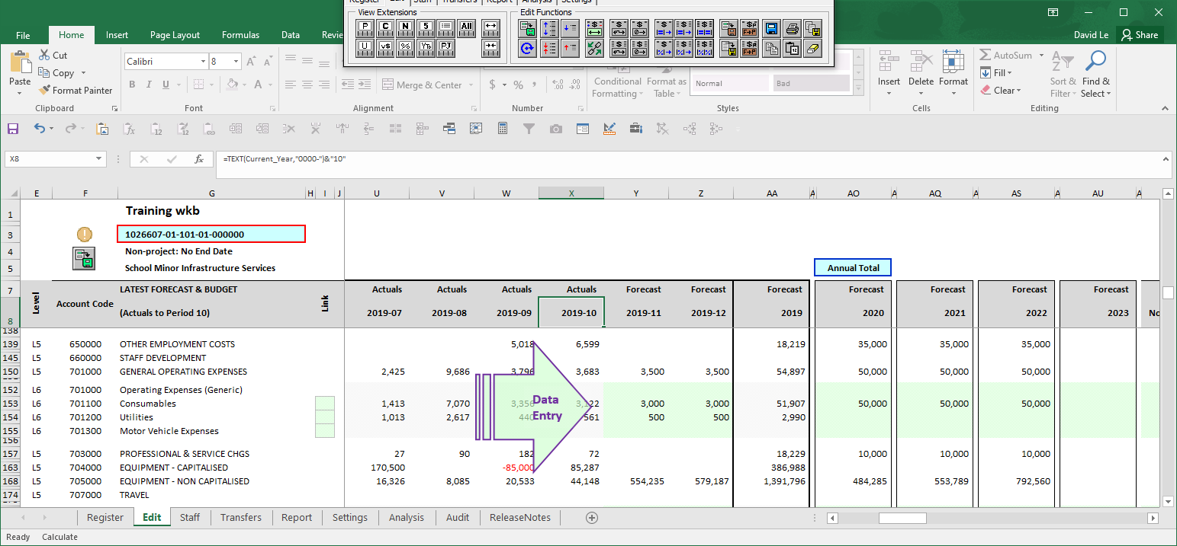 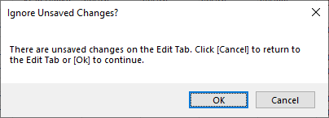

**Step 5. Report Tab (*after changes*)**

When you have made the desired changes to your forecast go to the [Report] tab and check that the changes made have had the expected result. Depending on the school / unit there will be various ways in which users will group and consolidate the reports for their schools.

**Note – for a detailed guide on using the reporting functionality see *Quick Reference Guide – “Guide to using report tab*”**

In the example below the report has been run for the total school –

1. The variance columns to compare different data sets can be changed by choosing [Comparison] as the Report Mode and selecting the Base Data set versus Comparison Data set from the blue shaded drop down boxes.

1. Data sets can be revealed and hidden depending on what data you need to see by using the View Extensions Buttons. These are toggle buttons that hide and reveal the different data sets *(****Hint*** *– Hovering your mouse over each button will display a tool tip).*

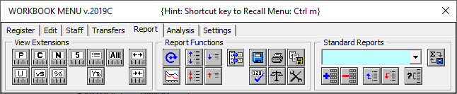

1. Check the forecast is as expected and compare it to the Last Submission Period or Budget data sets (If these columns are hidden they can be unhidden by clicking C:\DAVID\DAVID\1.Workbook\3. Dev\buttons\VarDollar.bmp.)

**NOTE - If the report is run for the whole school (as in the below example) the Forecast End of Year Total in Column AA is what will be loaded into the Reportal as your latest forecast (or if it is being used for Budgets columns AO, AQ, AS & AU will be loaded)**

1. If you need to make any changes go back to Step 2 or Step 4 and make any required adjustments to the forecast.
2. When the result is what you want to submit as your latest forecast go to Step 6.

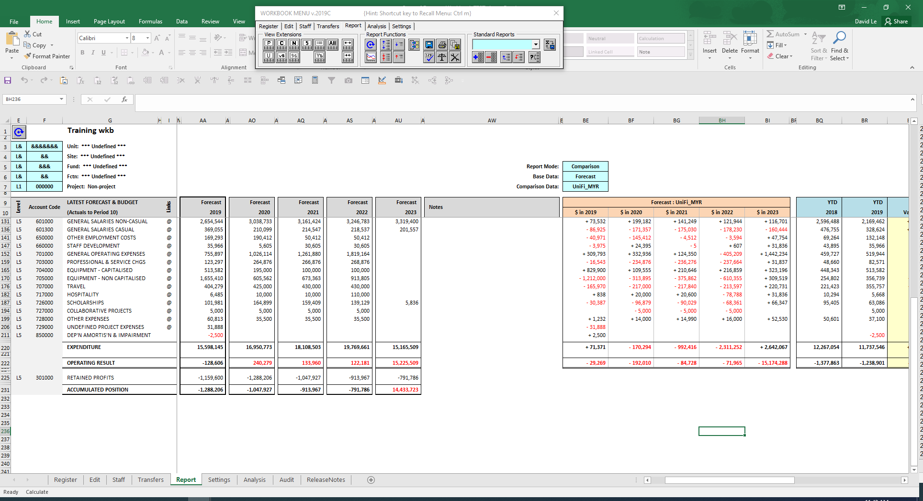

**Step 6. Export Data.**

Once the desired Forecast / Budget numbers have been produced depending on your school / unit you will then need to either send your completed workbook to your administrator or create the export file. See “***Quick Reference Guide – “Exporting forecast adjustments*”** for a guide on the export process.